**Individual Inventory Information System  
for PUP Office of Counseling and Psychological Services**

A System Proposal presented to the

Faculty of the College of Computer and Information Sciences,

Polytechnic University of the Philippines, Sta. Mesa, Manila

In partial fulfillment for the degree

Bachelor of Science in Information Technology

De Juan, Rona May Z.

Javier, Jaywel B.

Marzan, Reagel Khen A.

Tanoy, Ace Anthony D.

***Proponents***

**August, 2018**

**Table of Contents**

**Chapter 1 – Introduction** 3

**1.1.** **Project Context** 3

**1.2.** **Technical Background** 4

1.2.1. Equipment/Hardware 4

1.2.2. Software 5

1.2.3. Peopleware/Manpower 5

1.2.4. Network Infrastructure/Architecture 6

1.2.5. Storage, Backup and Recovery Procedure 6

1.2.6. Security Procedures 6

1.2.7. Policies and Procedures 7

1.2.8. Data and Process 10

**1.3.** **Problem Analysis** 11

1.3.1. Fishbone Diagram 11

1.3.2. Problem and Solution Statement 12

1.3.3. Problem – Requirements Matrix 13

**1.4.** **Purpose and Description** 14

**1.5.** **Specific Objectives** 15

**1.6.** **Scope and Limitations** 15

**Chapter 2 – Review of Related Literature/Systems** 17

**Chapter 3 – Methodology** 29

**3.1.** **Requirements Analysis** 29

3.1.1. Requirements – Features Matrix 29

3.1.2. Use Case Diagram 31

3.1.3. Use Case Report 34

**3.2.** **Design Specifications** 50

3.2.1. Activity Diagram 50

3.2.2. Class Diagram 53

3.2.3. GUI Design 54

3.2.4. Database Schema 8

3.2.5. Data Dictionary 8

**3.3.** **Development Methodology** 8

3.3.1. Process Model 8

3.3.2. Development Tools 8

**3.4.** **Test Methodology/Procedures** 8

**3.5.** **System Requirements** 8

**3.6.** **Quality Plan** 8

**3.7.** **Evaluation Plan** 9

**Chapter 4 – Results and Discussion** 10

**Chapter 5 – Conclusions and Recommendations** 11

**References** 12

**Appendices** 13

# **Chapter 1 – Introduction**

* 1. **Project Context**

The PUP Guidance and Counseling Office, which holds the Guidance, Counseling, and Testing Services (GCTS), assists students and coordinate their paths, molds their maturity, which will help them make intelligent decisions in every problem and adjustments in the school and community.

Its fundamental aim is to bring out the best in a person, especially the students, to help them decide on their own. Counseling, Information, Individual Inventory, Testing, and Research and Evaluation are the services it offer.

Individual Inventory Service collects and records information of students to utilize them as a basis for counselling and planning of seminars, workshops, lectures, training programs for greater self-improvement and self-realization, which is one of the services that is currently facing a major problem.

The service operates its processes manually. Starting from seeking the approval of the Vice President for Academic Affairs (VPAA) for the administration of Individual Inventory Record (IIR) and survey forms to each student, through an approval letter. Followed by having a request for the schedule of freshmen classes per section of the colleges in their respective department head. Down to their room-to-room administration of the forms.

After this is the arrangement of forms in alphabetical order per section to tally by the help of their student assistants and be able to produce the summary reports of annual student’s profile and survey results. Lastly, they will keep it enveloped and store inside the filing cabinet.

There is already an existing printable copy of the forms in their website but students rarely use it, as many of them are unaware of this service.

The GCTS Individual Inventory Service Management Information System and Survey Tool will help automate these processes. It can be part of the Student Information System (SIS), provided the student numbers, where the link of the web-based system will be sent as a message announcement or website notification. From there, the students will be able to fill-up the IRR and take up the survey form.

There will be no need for the approval of the VPAA or request for the schedule of classes every time they will be administering the forms. The system will do the arrangement and tallying of the records per section automatically especially in generating the statistical reports and survey results, which are going to be stored directly to the database.

Every time they need the record of a student for utilization or update in the information, it will be more accessible and faster. In addition, the creation of survey forms will be hassle-free. Thus, counseling the students and designing for the next program to conduct will be easier.

Effective counseling and programs will uplift the moral, social, and spiritual development of each students that help them be self-directive and productive citizens of society. These give them a greater understanding of themselves and the world around them.

* 1. **Technical Background**

1.2.1. Equipment/Hardware

Equipment and hardware used in the process of Individual Inventory Service based on the guidance office visit done:

Table 1.1 Equipment/Hardware

|  |  |  |
| --- | --- | --- |
| **Equipment/Hardware** | **Specifications** | **Quantity** |
| Desktop Computer | Compaq Windows 7 Ultimate Service Pack 1 64-bit  Processor: Intel Core i3-2100 CPU @ 3.10Ghz  RAM: 4GB | 10 |
| Printer | HP DeskJet GT 55820  Functions: Print, Scan, Copy, Wireless | 3 |
| Photocopier | Gestether Copy Printer 5307b | 1 |
| Router | D-Link DES-1024D 10/100 Fast Ethernet Switch | 1 |

* Desktop computers - used in creating forms needed in the Individual Inventory Service, such as the Individual Inventory Record (Form 1A – GCTS) and survey forms. These were also, where the softcopy of the tally records kept.
* Printers - used to produce hardcopies of the forms needed in the service. These include the approval letter sent to the Vice President of Academic Affairs (VPAA).
* Photocopier – used to reproduce the Individual Inventory Record (IIR) and survey forms in ratio to the number of students.
* Router – connects the computers into a network for faster file transfer.

The office do not lack of equipment needed to use in production of necessary forms needed in the service. In addition, the network of computers used for file sharing is not a problem.

1.2.2. Software

Table 1.2 Software

|  |  |
| --- | --- |
| **Software Program** | **Version** |
| Microsoft Word | 2010 |
| Microsoft Excel | 2010 |

* Microsoft Word – used to create word documents such as fill-up forms.
* Microsoft Excel – used to manually store tallied data

1.2.3. Peopleware/Manpower

People involved in working for the Individual Inventory Service are the guidance counselors and their student assistants.

Figure 1.1 Peopleware/Manpower

**GUIDANCE COUNSELOR**

**STUDENT ASSISTANTS**

Seeking the approval of the VPAA to administer the IIR and survey forms to students, requesting their class schedules in their department head, up to the room-to-room administration of these forms, are all the work of the guidance counselor.

Student assistants are the one who sort alphabetically the collected IRR and survey forms from the students per section. Then tallied manually for use in the annual students’ profile and as a basis of planning for the next program to conduct.

The counselor will then encode it in the computer and keep the collated forms in the filing cabinets.

The problem in the workforce arises only during the administration of IRR and survey forms, as they do not have enough staffs to help in distributing it to all the students.

1.2.4. Network Infrastructure/Architecture

Figure 1.2 Network Infrastructure/Architecture

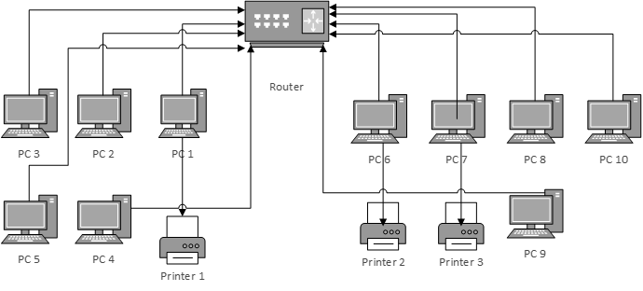

With the use of cables, the router connects the 10 workstations along with the three printers together over the same network.

1.2.5. Storage, Backup and Recovery Procedure

The Guidance, Counseling and Testing Services (GCTS) office keeps the forms collected after tallying. Each of it are enveloped and stored in the filing cabinet, arranged according to college.

As the office do not have a database to keep the records, it does not come with any backup or recovery procedure when any unwanted circumstances occur.

1.2.6. Security Procedures

One of the general objectives of the Guidance, Counseling and Testing Services (GCTS) is to secure the confidentially of the information of students. Records kept in the filing cabinets are limited to the counselor in-charge of it, securing its confidentiality.

1.2.7. Policies and Procedures

Table 1.3 Business Policies

|  |  |
| --- | --- |
| **BUSINESS POLICY ID** | **DEFINITION** |
| BR-1 | The students, who were not able to have their IIR yet, can fill up the forms directly in the office. |
| BP-2 | Privileged access to the IIR of students are limited to the counselors and student assistants. |
| BP-3 | Each IIR has approximately 5 years of lifetime after the student left the university, before its disposal. Any extension will need special inquiry in the GCTS office. |
| BP-4 | The IIR of faculty members are under the management of personnel, separate from the students. |
| BR-5 | The survey is not mandatory to each student. |

Table 1.4 Business Requirements

|  |  |
| --- | --- |
| **BUSINESS REQUIREMENTS ID** | **DEFINITION** |
| BR-1 | All students must have their individual inventory record in the office including new and transferee students. |
| BR-2 | The distribution of IIR and survey forms are through a room-to-room basis of first year students. |
| BR-3 | The GCTS office must first have the approval of the VPAA for the schedule of students and forms distribution. |
| BR-4 | The student must answer all the fields in the form. |

|  |  |
| --- | --- |
| **BUSINESS REQUIREMENTS ID** | **DEFINITION** |
| BR-5 | The summary of tally results per college arranged according to their department and section. |
| BR-6 | The permission of a GCTS counselor is necessary whenever there are updates or changes in a record. |
| BR-7 | The Commission on Higher Education (CHED) gets the tally results for the annual student profile. |

Figure 1.3 *Context Diagram*

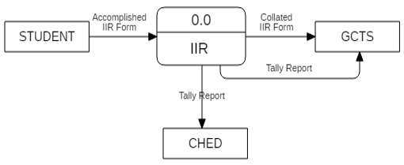

Figure 1.4 *Level 1 Data Flow Diagram*

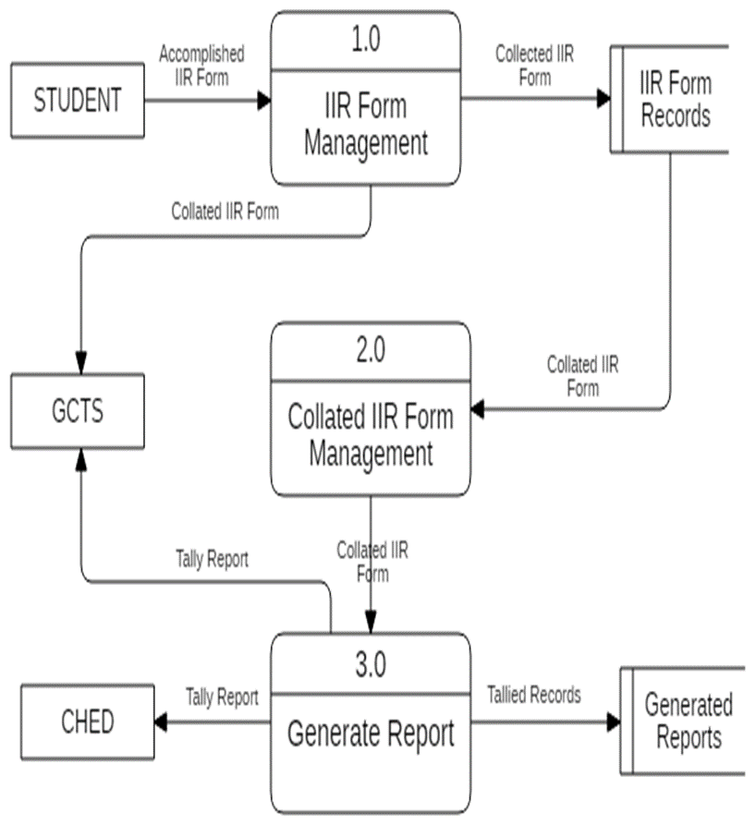

* + 1. Data and Process

Figure 1.5 *Flowchart*

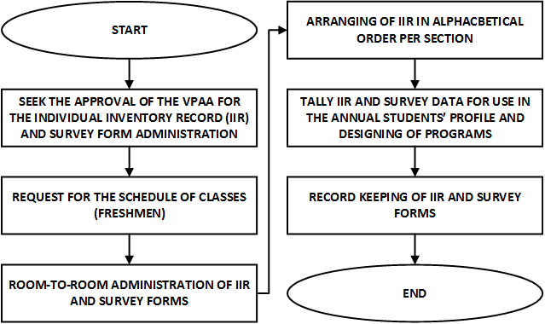

* 1. **Problem Analysis**
     1. Fishbone Diagram

Figure 1.6 *Fishbone Diagram*

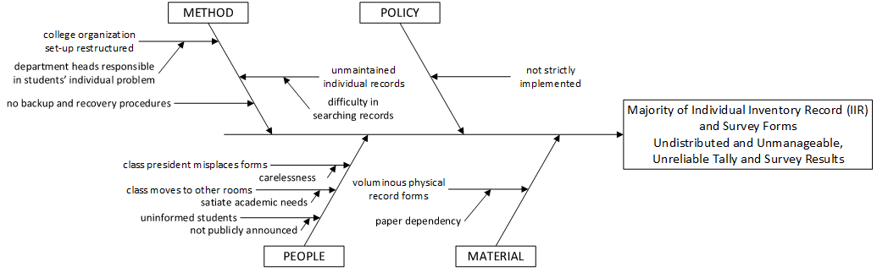

Majority of the Individual Inventory Record (IIR) forms are undistributed as the late President Dr. Mateo restructured the college organization setup in 1974 because department heads want to take responsibility of students’ individual problems this resulted to a change in the process of administrating IIR forms.

The current process increased the number of undistributed IIR forms. The current process have not strictly implemented its requirement of having the individual record of all students. When they administer the forms to a class and assign to class president the collection, it was often misplaced or no one comes back to the office. Sometimes when a counselor goes to the scheduled room of the class to distribute the forms, the class moves to other rooms for academic reasons like moving from lecture to laboratory rooms.

Many of the students are also unaware of this service as no public announcements or orientations done regarding this.

As the forms are undistributed, data gathered are limited resulting to unreliable results of tally.

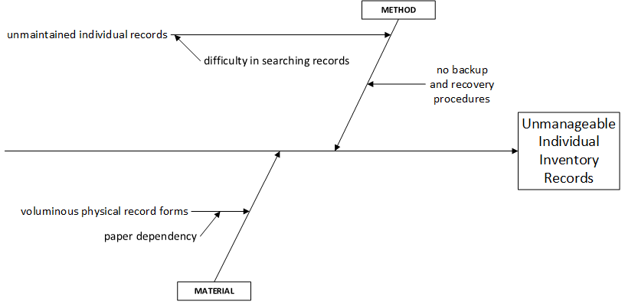

Fig. 1.5 *Fishbone Diagram*

Individual Inventory records are unmanageable as many of these are unmaintained because there is a difficulty in searching for a particular record to update due to the voluminous physical record forms dependent on papers stored in filing cabinets. Moreover, because the office do not have a database to store the records there is no backup and recovery procedures.

* + 1. Problem and Solution Statement

The Guidance, Counseling, and Testing Services (GCTS) is facing a major problem in the current process of its Individual Inventory Service. Majority of the IIR forms are undistributed to all the students, which is the main objective of this service - to gather necessary information of each student to help them have an effective counseling, as this also required in annual students’ profile. This in return affects the tally results generated from the gathered data collected by Commission on Higher Education (CHED). Records are also unmanageable as they hold thousands of students in a manual process, making it hard for them to maintain each record of students.

The proponents come to a solution of making a new systematic process to work on the service. A web-based management and information system that automates the process of the Individual Inventory Service.

It will address the problem in managing the records as searching for a record to update will be faster provided the system database that eliminates the dependency on voluminous physical record forms. Backup and recovering the records will be also included.

The system is propose to be link on the SIS as a survey, message announcement, and website notification mandating each student to fill-up the IIR form. Thus, increase the probability of distribution of forms to all the students, resulting to a more reliable tally results collected by CHED.

* + 1. Problem – Requirements Matrix

|  |  |  |  |
| --- | --- | --- | --- |
| **Reference** | **Page No.** | **Problem** | **Requirements** |
| FBD 1.1 | 11 | The current process of enrollment does not include filling up of IIR form | A new systematic process to take account in filling up of IIR forms |
| FBD 1.1 | 11 | The administration of IIR forms are not strictly implemented | Require the students to fill up the IIR form |
| FBD 1.1 | 11 | Class presidents assigned to keep the administered IIR forms from the class are usually misplaced | Change the room-to-room process of administering IIR forms |
| FBD 1.1 | 11 | Some class scheduled for the administration of IIR move to another room to satiate their academic needs | Change the room-to-room process of administering IIR forms |
| FBD 1.1 | 11 | Many students are unfamiliar with the individual inventory service GCTS provides | Orient the students about the existence of IIR form |
| FBD 1.1 | 11 | Tally results are unreliable as the records collated are incomplete | Increase the reliability of the tally result |
| FBD 1.2 | 12 | Unmaintained individual record results to unmanageable IIR | Any updates or maintenance needed in any record must be addressed immediately |
| FBD 1.2 | 12 | Currently there are no backup and recovery procedures in the management of the IIR | Existing database that will provide a backup and of records and recovery procedures to the management of IIRs |
| FBD 1.2 | 12 | Voluminous record in paper forms makes it difficult to manage | Eliminate the dependency on papers in the management of individual inventory records |

Table 1.3. *Problem-Requirements Matrix*

* 1. **Purpose and Description**

To propose a solution to the current process of the Individual Inventory Service of the Guidance, Counseling, and Testing Services (GCTS) that will bring back the strength of its objective, to collect all the individual record of students. The Guidance, Counseling, and Testing Services (GCTS) Individual Inventory Service Management and Information System will automate the flow of its process. A web-based system shown through Student Information System (SIS) as a link where they will be required to fill-up the Individual Inventory Record Form (IIR) to distribute the form to all students.

This is important, as the Commission on Higher Education (CHED) requires an annual student’s record from the GCTS. Moreover, this study aims to eliminate unnecessary process in collating and managing IIR Forms. Among such process is the need for the approval of the VPAA or request for the schedule of classes in administering each form, as the form is accessible through the SIS.

The system will automatically arrange and tally all the records as to college, department, and section. Furthermore, it will produce statistical or demographic records. In that manner, there will be proper management and record keeping of all the information in the database.

Manual tallying will be now be converted to automate tallying; hence, it will secure the confidentiality of data. This will also serve as backup copies and is beneficial in times of unpredictable circumstances. It will answer the problem in accessibility and updating records.

Finally, counseling of the students will be easier because there will be a ready firsthand information about the student, starting a conversation will not be a problem. The elimination of the use of paper and pen results to increased accuracy of information. Effective counseling uplifts the moral, social, and spiritual development of each students will help them be self-directive and productive citizens of society.

This gives back the strength of the Guidance, Counseling, and Testing Services (GCTS) in providing quality Individual Inventory Service vanished through time.

* 1. **Specific Objectives**

In response to the problems faced by the Guidance Counseling and Testing Services (GCTS) with their current manual operation of Individual Inventory Service from distribution up to the tallying of records, this project aims to:

1. To enumerate the problems arise in the current process.
2. To evaluate the existing hardware, software, workers and process currently in use.
3. To propose and develop a system that will satiate the specified needs and requirements.
4. To identify the requirements of the proposed solution through a systematic review of related literature and systems.
5. To design a web-based system linked through the SIS to help in solving the specified problems.
   1. **Scope and Limitations**

The scope of this study covers only the Individual Inventory Service of the Guidance, Counseling, and Testing Services (GCTS) in the Polytechnic University of the Philippines.

Automating the processes in the service. It includes the distribution of Individual Inventory Record limited to the students of PUP Sta. Mesa, sorting and tallying of their records, and storing to the system’s database linked through the SIS. Each student can have an account according to the student type: laboratory high school, senior high school, college, or graduate school student. With it, they could fill up the IIR form, view and update it whenever needed.

Management of records done by the counselor enables them add an account and view, edit, and delete the existing records. Whereas, staffs only allowed adding an account and view and edit the existing records. With the collated records tally results produced as an output.

The system is solely for PUP students, PUP Guidance Counseling, and Testing Services counselor and staffs who will use the system, any other users and outsiders not given permission prohibited to use the system.

# **Chapter 2 – Review of Related Literature/Systems**

This chapter discuss further the concept of guidance, counseling and testing services in education, specifically in the tertiary level. It also covers an overview of the individual inventory service especially in the guidance department of universities. Importance of a management information system and MISs that has been studied and developed to improve and make advancements also reviewed.

**Guidance, Counseling, and Testing**

**[A] Guidance**

Guidance is simply the process of helping or directing someone on what to do towards a particular situation. A type of guidance that is concerned with education is the Educational Guidance, the one that a student may need while taking the journey in school. It helps students to have intelligent decisions and adjust responsibly to different life situations.

In the book by Clement (2015), ‘Management of Nursing Services and Education, 2nd Edition’, stated a definition by Traxien, “Educational guidance enables each individual understand his abilities, develop them as far as possible and relate them to the goals of life and reach that stage of mature self-guidance as a desirable citizen of a democratic social order.”

It therefore helps a student to bring out the best in him, develop and mold his maturity and intelligence as he walk the path on his own journey and adjust to it correspondingly making him achieve his goals to fully become an independent citizen the society desires.

**[B] Counseling**

Counseling on the other hand, as defined in the Merriam-Webster dictionary, is the professional guidance to individuals utilizing psychological methods in the collection of case history data, personal interview, and testing interests and aptitudes.

The 92nd Volume of the ‘Journal of Counseling & Development’ in 2014, a peer-reviewed academic journal published quarterly by Wiley-Blackwell on behalf of the American Counseling Association, world's largest association exclusively representing professional counselors in various practice settings, made a consensus definition of counseling that was accepted in 2013. The 29 major counseling organizations endorsed the definition: “Counseling is a professional relationship that empowers diverse individuals, families, and groups to accomplish mental health, wellness, education, and career goals.”

The definition gave a finally profession-wide clarity as to what it means to engage in professional counseling, which is to strengthen and unite variants of individuals and groups through professional relationship to help in controlling life through a healthy mind to secure education and achieve goals.

Counseling, like Guidance, is a psychological field that helps in the treatment and rehabilitation of an individual suffering from a mental illness or disorder. It is just counseling deals with research and applied work to provide supervision while the latter only deals with assisting counselee in their need to choose the right course of action. It means counseling has a broader scope as compared to guidance.

**[C] Testing**

Testing is required to help assessing students in guidance and counseling. Assessment is an action of making a judgment after various test have done.

Samuel T. Gladding (2013) discussed in his book, ‘Counseling a Comprehensive Profession (7th ed.), that testing refers to the measurement of psychological phenomena with instruments or specified procedures.

These phenomena exist but cannot be directly observe. It includes emotional states such as happiness, or cognitive traits such as intelligence, or even psychological states such as stress but with the help of instruments like aptitude and personality tests, it becomes measurable.

In the same book, assessment defined as the collection of information in the counseling relationship. This is an essential process to make an effective counseling through identifying problems, planning interventions, evaluating and/or diagnosing counselee, and informing them.

**Guidance, Counseling, and Testing Services in PUP**

These three services altogether function as one in the Polytechnic University of the Philippines through the Guidance, Counseling, and Testing Services (GCTS) Office. Its role is to maximize the students’ potentials to become self-directive and productive citizens of society. It is committed to enhance and uplift the moral, social, and spiritual development of every PUPian.

As posted in the website of PUP, the historical background of the GCTS is as follows:

Guidance and Counseling Office initiated in the university in the early 50s when PUP was still Philippine College of Commerce (PCC) holding small enrollments. By that time, the office do not have any well-defined structures and programs and the counselors assigned were the faculty members assigned to the Office of Student Affairs. Many of them lacked in training and skills necessary for the job.

During the early 70s, PCC, a hotbed of student activism, ordered closed by late President Ferdinand E. Marcos. It lasted 3 months except for the Guidance Office that remained closed. Revived with only two counselors then reorganized and placed under the Registrar’s Office.

In 1974, Dr. Pablo T. Mateo was the Officer-in-Charge of PCC, restructured the College organization set-up, this is when individual problem of the students regarding guidance and counseling became the responsibility of their respective department heads.

In the same year, Isabelo T. Crisostomo appointed as the Acting President that is when the Guidance and Counseling Office began to play a more significant role. The Office acted as adviser on student needs and problems when re-organized into a center directly under the Office of the President. Later on new counselors with the degree in psychology designated to help the Director in the implementation of its program. This is when College Entrance Test constructed to screen the growing numbers of freshmen applicants.

In the late 70s, 1997, during the administration of Dr. Pablo T. Mateo replacing Crisostomo, the Office extended its services to the PUP Laboratory High School and the PCC converted into a University. The Office once again placed under the Dean of Student Services.

In 1986, Dr. Nemesion E. Prudente reassigned as the PUP President after the EDSA I Revolution. His all-out support to the office paved the way for its full existence and development. Guidance and Counseling Office at the Unyon ng Mag-aaral Building developed into a very significant part of the University coordinating with other units and departments toward the total development of the students.

Before Dr. Prudente’s term ended, the Office transferred at the South Wing’s fifth floor. Its testing services extended to other government agencies for the hiring of the rank-and-file and the promotion of supervisory applicants. These made possible under Memorandum of Agreements between the Bagong Katipunan Foundation and government agencies such as the Department of Science and Technology (DOST), National Dairy Authority, Philippine Carabao under the Department of Agriculture and Philippine Retirement Authority. The latest addition to the list of government agencies is the Commission on Higher Education.

During the term of Dr. Zenaida A. Olonan, Guidance and Counseling Office transferred to the Ground Floor of North Wing facing the interfaith Chapel to reach out more students making the program available to them.

In 1998, Dr. Ofelia M. Carague appointed as the University President. Guidance and Counseling Office transferred to the second floor of the Charlie Del Rosario Student Development Center (Formerly Unyon ng Mag-aaral Building).

Moreover, on 2007, Acting President Dr. Dante G. Guevarra’s proposal to add the guidance fee on the miscellaneous accepted.

Until the present time, 2018, under the administration of President Emanuel C. de Guzman, the major problem in the Individual Inventory Service of the Guidance, Counseling, and Testing Service (GCTS) Office still encountered.

**Individual Inventory Service**

**[A] Overview**

“The service is focused on how one gathers adequate information so you can give proper help.” (McGuire, 2015)

Individual Inventory is a service that most Guidance, Counseling, and Testing Offices have. It consists of all the information gathered about each students through measuring instruments like tests or Individual Inventory forms. These will be keep confidential and reserve while the student is still in school for future use in guidance and counseling.

In the book ‘Implementing a Comprehensive Guidance and Counseling Program in the Philippines’ (Villar, 2009), she defined the nature and purpose of Individual Inventory as a systematic collection, evaluation, and interpretation of data to identify the characteristics and potential of every counselee.

It enables students to develop a deeper and fuller self-awareness. It also helps in creating appropriate plans for improving the quality of life through self-understanding.

Furthermore, it enables the counselor to get to know the student. Facilitate its self-awareness, self-understanding and decision-making. Making the counselor ascertain appropriate avenues for the student to pursue and determine the best options for helping him/her, assisting its significant others in understanding.

It therefore gives the administration and faculty an idea of the profile of the school population, the appropriate strategies to needs, interest, and values. Lastly, the strengths and passions channeled to appropriate goals.

Parents or guardians also have a basis for understanding their children better, responding more sensibly to them.

**[B] Historical Perspectives**

Individual Inventory is already in great use way back the 20th century. Several studies proved that Individual Inventory is effective in making analysis of an individual to help administrating guidance services in schools.

Anderson (1954), stated in his study ‘Current Practices in the Organization and Administration of Guidance Services in Ninety-four Selected Secondary Schools’, that dealing with the analysis of individual he reported practices rated "Good" to "Outstanding" by half or more of the schools in each group.

These includes: use of test and inventory results, keeping inventories up to date, using all inventory results in counseling, maintaining an inventory for each student, having inventories accessible to teachers. Attempting to discover special aptitudes of students, attempting to learn students' special interests, having information available on students' hobbies and work experience, having educational plans information available, and having occupational plans information available.

In his conclusions, Anderson noted that among practices which appeared, fairly well develop in majority of the schools was the analysis of the individual through tests and inventories. On the other hand, the analysis of the individual through such techniques as anecdotal records, rating scales, and work experience, were less well performed and greatly in need of expansion.

Zeran, La llas, and Wegner (1964) in their study ‘Guidance: Theory and Practice’, believed that to understand the individual and help him, we need a personalized look at the many persons, places and events which contributed to his unique personality.

This personalized look at the individual, his environment, and his experiences is individual analysis. It is a basic tool for collecting and recording those facts about a student, which are most useful in analyzing his behavior in the educational setting.

Moser and Moser (1963) joined in this belief in their study ‘Counseling and Guidance: An Exploration.’ They emphasized the nature of counseling work in the schools demands a system for keeping and maintaining detailed information about each student.

The inventory is a special responsibility of the guidance staff, but its utility is school-wide; and for this reason, the records should be centrally located and accessible to all qualified personnel. It should concentrate on those areas that can be helpful to the student's growth and development, avoiding, as much as possible, petty grievances against students.

On this point, they expressed concern for the ethics of confidentiality, which must kept in mind by all who have access to these records. These writers listed data, which are usually included in the cumulative folder as being: census information, health information, test information, anecdotal records, autobiographies and samples or work, academic grades, and rating scales. Further expressed the necessity for this, being a continuous record and be currently keep.

**[C] Individual Inventory among Universities**

Services in the guidance department varies among universities. In the Philippines, well-known universities take use of this service to achieve its objectives and provide quality service to students.

In the Polytechnic University of the Philippines (PUP), the role of the Guidance, Counseling and Testing Service (GCTS) is to mold the student through education with the ultimate goal of making him a better person. Its services implemented within the school year to benefit the students and the entire academic community, as well.

This includes the Individual Inventory Service; it includes collecting, recording, and utilizing information about the students, done through the accomplishment of the Individual Inventory Record Form (Form1A -GCTS), which summarizes the contents there is in the Personal Data Sheet (PDS) or the Cumulative Record, results of psychological tests and previous interviews. The data gathered used as basis for counseling.

During the guidance visit done by Aspiras & Ordiales in 2015 at the Our Lady of Peace Guidance Center, they were able to view immediately the tally of records, 75% of its clients are religious (nuns, priests, brothers, etc.), 25% are lay people and others. Most problems/issues dealt with includes old age crisis, mid-life crisis, issues concerning career, etc.

That is because the guidance uses Individual Inventory to keep the records of its clients and clears it out every 10 years as part of the proper disposal of inventory.

**Management Information System**

**[A] Overview**

Kenneth C. Laudon (2005) stated in ‘Management Information Systems: Managing the Digital Firm - 9th Edition’ that a management information system (MIS) is a computerized database of information organized and programmed in such a way that it produces regular reports on operations for every level of management in a company.

It is usually also possible to obtain special reports from the system easily. The main purpose of the MIS is to give managers feedback about their own performance; top management can monitor the company as a whole.

Information displayed by the MIS typically shows "actual" data over against "planned" results and results from a year before; thus, it measures progress against goals. The MIS receives data from company units and functions. Some of the data are collected automatically from computer-linked checkout counters; others keyed in at periodic intervals.

Routine reports are pre-program and run at intervals or on demand. While others obtained using built-in query languages, managers to check on status at desk-side computers connected to the MIS by networks use display functions built into the system. Many sophisticated systems also monitor and display the performance of the company's stock.

**[A] Importance of MIS**

Jane P. Laudon (2005) stated in ‘Management Information Systems: Managing the Digital Firm - 9th Edition’ that midway through the first decade of the 21st century the narrowly conceived idea of the MIS has become somewhat fuzzy. Management information systems, of course, are still doing their jobs, but their function is now one among many others that feed information to people in business to help them manage.

Systems are available for computer-assisted design and manufacturing (CAD-CAM); computers supervise industrial processes in power, chemicals, petrochemicals, pipelines, transport systems, etc. Systems manage and transfer money worldwide and communicate worldwide.

Virtually all major administrative functions supported by automated system. Many people now file their taxes over the Internet and have their refunds credited (or money owning deducted) from bank accounts automatically. MIS was thus the first major system of the Information Age. At present, the initials IT are coming into universal use. "Information Technology" is now the category to designate all software-hardware-communications structures that today work like a virtual nervous system of society at all levels.

If MIS defined as a computer-based coherent arrangement of information aiding the management function, a small office running even a single computer appropriately equipped and connected is operating a management information system. The term used to be restricted to large systems running on mainframes, but that dated concept is no longer meaningful.

A medical practice with a single doctor running software for billing customers, scheduling appointments, connected by the Internet to a network of insurance companies, cross-linked to accounting software capable of cutting checks is de facto an MIS.

In the same vein, a small manufacturer's rep organization with three principals on the road and an administrative manager at the home office has an MIS system that system becomes the link between all the parts.

It can link to the inventory systems, handle accounting, and serves as the base of communications with each rep, each one carrying a laptop. MIS has come of age and has become an integral part of small offices that help the school.

Here are some studies and systems developed that attest the effectiveness of a computerized record-keeping or management information system in relate with the topic:

**[B] MIS in the Philippines**

**Automatic Health Diagnostic and Medical Records System**

Castillo et al. (2013) conducted a study to determine if an Automatic Health Diagnostic and Medical Records System would ease and minimize the time of consultation in clinic. The health kiosk system acts as a medium for the patients to explain their symptoms instead of waiting in line. The system can be used in identify medical histories, patient registration, self-assessment and patient access to records.

However, it cannot give drug prescriptions and does not cover unusual illnesses. In addition, it cannot handle complex sentences that need understanding. It do not have NLP tools and gives its outputs by determining the keywords only, so the patient is recommended to submit the results to the doctor after the transaction to secure the safeness.

After conducting a survey to nursing and psychology students of Our Lady of Fatima University, the proponents have concluded that the system is very accommodating and is acceptable by users in terms of system performance, accuracy and user-friendliness.

**Web**–**based Student Guidance Information System**

Del Rosario et al. (2012) presented a system that can record the students’ transaction with the Guidance Office in terms of online counseling. The system fully establish an efficient and effective way of communication between the guidance office and students through the online counseling and forums.

The system has the full capability of keeping track of student records as well as their violations by means of their individual student profile records in the database. Looking-up of student records is a lot easier because of the search engine present in every student list pages. Counselors can now efficiently record students’ violation because of the auto-fill function of the system. The system can generate data reports needed by the guidance office such as member’s report and student violation reports, given the range specified by the user.

The researchers had successfully incorporated Online Counseling function, Career Guidance which includes the Career Review Test and list of Universities and Colleges, Personality and Non-standardized IQ tests, forums wherein the members of the site can interact, Virtual Bulletin Board that shows the current news and events of the school, reports that are needed for reference and recording purposes.

Offensive, foul and abusive words moderated in the Forum page through the “report abuse” button present in any comment or post. The system also offers security features such as login function and functionality restrictions to non-Administrator accounts.

It received an 89.6% acceptance rating, making the system more likely to be implemented by the client, having its strongest point on usability and weakest in maintainability. High ratings from the clientele signify eager approval of this system and some further expansions.

**[C] MIS International**

Studies conducted in the outside the country to test the effectiveness of having a Management Information System.

**E-Student Guidance System**

Kali et al. (2014) introduced a decision support system that helps the students to take the right decision during the registration process; it shrinks the time spent in asking others which courses to register. Its aim is to reduce the time lost in the process of traditional system. To help the students choose the appropriate courses that meets his/her needs and improve the usefulness and usability of the user interface design.

At the end, the proponents decided to work on the establishment of an integrated website to help the students make the correct decision before the registration of the sections.

**A Web Based Career Guidance Information System for Pre-Tertiary Institution Students in Nigeria**

Abisoye et al. (2015) designed an Online Career Guidance Information System targeting students in pre tertiary institutions in Nigeria to solve the problems in the existing manual Career Guidance System with human counselors in charge.

This includes the few number of human counselors, unavailability of a counselor in a good number of schools; few numbers of counselors attending to students during school hours and the office of a counselor in schools are so unpopular that students hardly meet them for career counseling.

The scripting languages employed are PHP, MySQL, HTML, Java Script and CSS.

The system implemented and tested with 50 students and 76% of them found the career system very useful.

These studies paved the way to the possibility of developing a web-based management and information system that will aid the prolonged problem in Individual Inventory Service of the Guidance, Counseling, and Testing Services (GCTS) in the Polytechnic University of the Philippines.

**Analysis and Synthesis**

Integrating concepts, theories and studies as well as learning from other books, studies, websites we can guarantee that this will help us in building the system and its framework.

Every process has a beginning we can begin integrating these by gathering information about the client. Moreover, what does our client do, in this case Guidance, Counselling and Testing Services Office.

Guidance is a very important part of anyone, because if even they seem reliable or mature enough they need guidance, Guidance is showing options for the person to feel like they have a path that they are taking and is not lost on what to do about life or a certain topic regarding their life.

As well as counselling which is also a form of showing options to the person is like guidance but instead of showing them a path is teaching them on what to do to see the path in the first place, basically removing the blindness in their eyes.

Testing is also important as it lets students gauge themselves and challenge as a form of motivation for students.

These three services altogether function as one in the Polytechnic University of the Philippines through the Guidance, Counselling, and Testing Services (GCTS) Office. Its role is to maximize the students’ potentials to become self-directive and productive citizens of society. It is committed to enhance and uplift the moral, social, and spiritual development of every PUPian.

As posted in the website of PUP, the historical background of the GCTS is as follows:

Guidance and Counselling Office initiated in the university in the early 50s when PUP was still Philippine College of Commerce (PCC) holding small enrolments. By that time, the office do not have any well-defined structures and programs and the counsellors assigned were the faculty members assigned to the Office of Student Affairs, Many of them lacked in training and skills necessary for the job.

During the early 70s, PCC, a hotbed of student activism, ordered closed by late President Ferdinand E. Marcos. It lasted 3 months except for the Guidance Office that remained closed. Revived with only two counsellors then reorganized and placed under the Registrar’s Office.

We also learned that because they changed the college organization set-up because the students increased their number by each year, it became harder to track of them and their specific Individual Inventory Report.

Now while knowing this, the next process is related system to the proposal, so we can learn from what gave their system the edge or we can learn from what not to do.

We started from small-related systems and broader ones like Information Systems; because Individual Inventory is a service that most Guidance, Counselling, and Testing Offices have. It consists of all the information gathered about each student through measuring instruments like tests or Individual Inventory forms. This is very important, as most likely we will be dealing with sensitive data.

Now in order to help GCTS more it cannot be just a simple Information System, we need to manage data too and specify which information and to help GCTS.

Management information systems are helpful because it fits right at what GCTS needs.

MIS defined as a computer-based coherent arrangement of information aiding the management function, a small office running even a single computer appropriately equipped and connected is operating a management information system. The term used to be restricted to large systems running on mainframes, but that dated concept is no longer meaningful.

# **Chapter 3 – Methodology**

* 1. **Requirements Analysis** 
     1. Requirements – Features Matrix

|  |  |  |  |  |
| --- | --- | --- | --- | --- |
| **Features**  **Requirements** | A web-based automated version of the IIR forms | Linkage of the system to the SIS through message announcement, website notification or in the form of survey | Records are organized and safely stored in a database for easy recovery process | A search feature available, for the record to be easily retrieved and maintained |
| A systematic process to take account in filling up of IIR forms |  |  |  |  |
| Mandate all students to fill up the IIR forms |  |  |  |  |
| Change the room-to-room process of administrating of IIR forms |  |  |  |  |
| Any update or maintenance needed in any record must be addressed immediately |  |  |  |  |
| To have an existing database that will provide a backup of records and recovery procedures to the management of IIRs |  |  |  |  |
| Eliminate the dependency on papers in the IIR forms |  |  |  |  |
| Require the students to fill up all the fields in the form |  |  |  |  |

Table 1.4. *Requirements-Features Matrix*

* + 1. Use Case Diagram

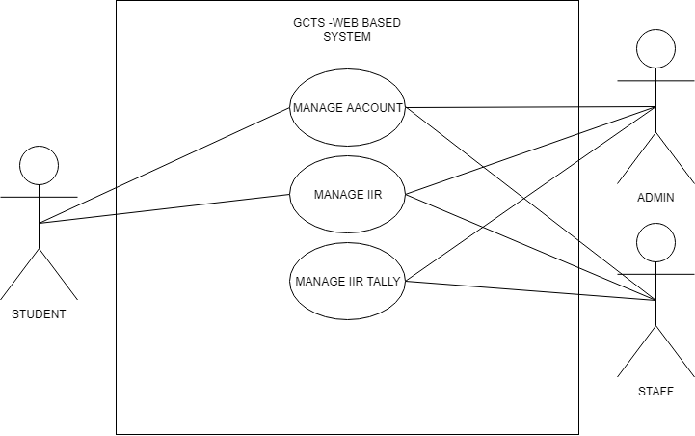Fig. 3.1 *Top-level System Use Case Diagram*

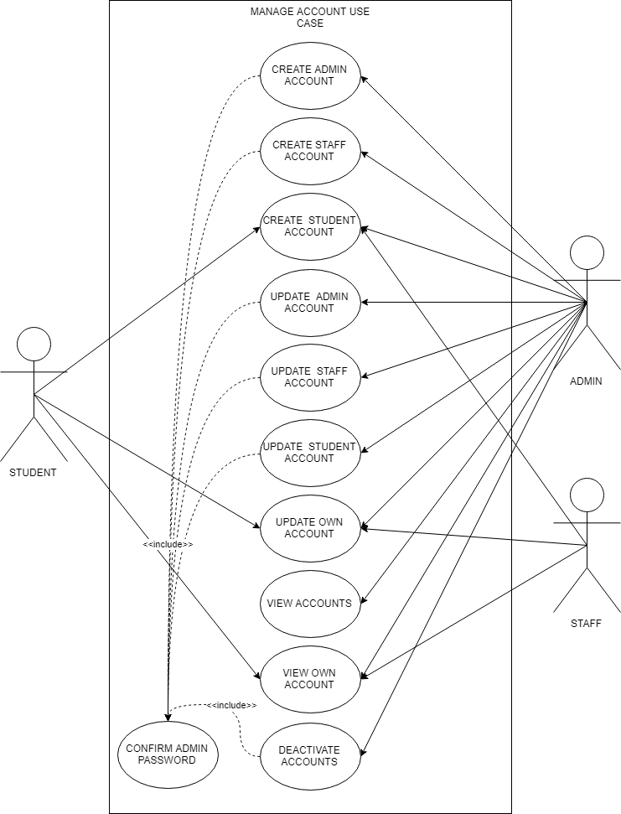Fig. 3.2 *Manage Account Use Case Diagram*

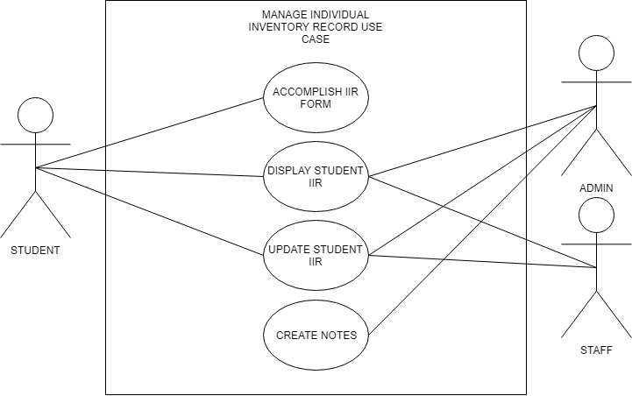

Fig. 3.3 *Manage Individual Inventory Record Use Case Diagram*

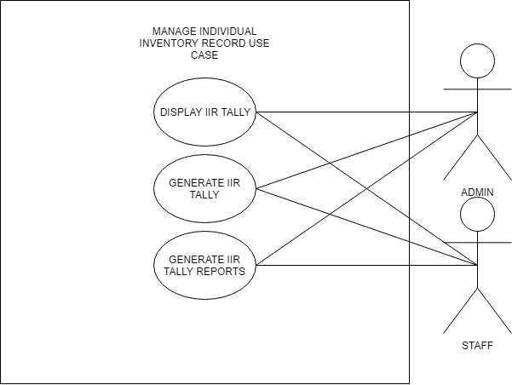

Fig. 3.4 Manage Individual Inventory Record Use Case Diagram

* + 1. Use Case Report

**Manage Account**

|  |  |
| --- | --- |
| **Use Case** | UC-1 |
| **Use Case Name** | Create Admin Account |
| **Actors** | Administrator – Has the highest access level for the system |
| **Purpose** | 1. To create an account for another admin |
| **Brief Description** | This covers the introduction of new admin. |
| **Pre-condition/s** | 1. Permission of an admin 2. The candidate for an admin must be a counselor |
| **Post-condition/s** | 1. New admin account is created 2. The admin can now login and use the system. |
| **Frequency of use** | Whenever a new counselor is hired/introduced |

|  |  |
| --- | --- |
| **BASIC FLOW: Admin Side** | |
| **Actor Action** | **System Response** |
| 1. The admin should login to his/her account | 1. The system will verify the login data |
| 1. Click the manage accounts tab | 1. Manage accounts tab will open |
| 1. Click the admin accounts tab | 1. The system will redirect to the list of admin accounts |
| 1. Click add an account | 1. A modal will open containing the form for registration |
| 1. Fill up the necessary admin details |  |
| 1. Click Submit | 1. A modal for confirmation of admin’s password will be prompted |
| 1. Enter password |  |
| 1. Click Submit | 1. The system will verify the admin’s password and create the account |
| **ALTERNATE FLOW** | |
| **Actor Action** | **System Response** |
| **Line 1** |  |
| 1. The admin will have to sign in again or ask for another admin’s help for confirmation of login details. | 1. The system will verify the login data. |
| **Line 12** |  |
| 1. The admin will need to re-enter his/her password for confirmation. | 1. The system will validate the admin’s password |

|  |  |
| --- | --- |
| **Use Case** | UC-2 |
| **Use Case Name** | Create Staff Account |
| **Actors** | Administrator |
| **Purpose** | 1. To create an account for a staff |
| **Brief Description** | This covers the introduction of new staff. |
| **Pre-condition/s** | 1. Permission of an admin 2. The candidate for a staff must be a Student Assistant in the Guidance Counselling and Testing Services office. |
| **Post-condition/s** | 1. New staff account is created 2. The admin can now login and use the system. |
| **Frequency of use** | Whenever a new Student Assistant is hired. |

|  |  |
| --- | --- |
| **BASIC FLOW: Admin Side** | |
| **Actor Action** | **System Response** |
| 1. The admin should login to his/her account | 1. The system will verify the login data |
| 1. Click the manage accounts tab | 1. Manage accounts tab will open |
| 1. Click the staff accounts tab | 1. The system will redirect to the list of staff accounts |
| 1. Click add an account | 1. A modal will open containing the form for registration |
| 1. Fill up the necessary staff details |  |
| 1. Click Submit | 1. A modal for confirmation of admin’s password will be prompted |
| 1. Enter password |  |
| 1. Click Submit | 1. The system will verify the admin’s password and create the account |
| **ALTERNATE FLOW** | |
| **Actor Action** | **System Response** |
| **Line 1** |  |
| 1. The admin will have to sign in again or ask for another admin’s help for confirmation of login details. | 1. The system will verify the login data. |
| **Line 12** |  |
| 1. The admin will need to re-enter his/her password for confirmation. | 1. The system will validate the admin’s password |

|  |  |
| --- | --- |
| **Use Case** | UC-3 |
| **Use Case Name** | Create Student Account |
| **Actors** | Administrator/Staff/Student |
| **Purpose** | 1. To create an account for a student 2. For the student to be able to fill up an individual inventory record form. |
| **Brief Description** | This covers the introduction of new staff. |
| **Pre-condition/s** | 1. Permission of an admin/staff 2. The student must be a student from the Polytechnic University of the Philippines. |
| **Post-condition/s** | 1. New student account is created 2. The student can now login and fill up an individual inventory form. |
| **Frequency of use** | As frequent as there are students that has to fill up the individual inventory record form. |

|  |  |
| --- | --- |
| **BASIC FLOW: Front Side** | |
| **Actor Action** | **System Response** |
| 1. Click sign up for an account | 1. A page will open containing the form for registration |
| 1. Fill up the necessary staff details |  |
| 1. Click Submit | 1. The system will create the account |

|  |  |
| --- | --- |
| **BASIC FLOW: Admin Side** | |
| **Actor Action** | **System Response** |
| 1. The admin/staff should login to his/her account | 1. The system will verify the login data |
| 1. Click the manage accounts tab | 1. Manage accounts tab will open |
| 1. Click the student accounts tab | 1. The system will redirect to the list of student accounts |
| 1. Click add an account | 1. A modal will open containing the form for registration |
| 1. Fill up the necessary staff details |  |
| 1. Click Submit | 1. The system will create the account |
| **ALTERNATE FLOW** | |
| **Actor Action** | **System Response** |
| **Line 1** |  |
| 1. The admin/staff will have to sign in again or ask for another admin’s help for confirmation of login details. | 1. The system will verify the login data. |

|  |  |
| --- | --- |
| **Use Case** | UC-4 |
| **Use Case Name** | Update Admin Account |
| **Actors** | Administrator |
| **Purpose** | 1. To update an admin’s account details. 2. To reset or change an admin’s password. |
| **Brief Description** | This covers the retyping of an admin’s details for update. |
| **Pre-condition/s** | 1. The admin must have an account. |
| **Post-condition/s** | 1. The admin’s account will be updated 2. Co-admin’s password will change. |
| **Frequency of use** | Whenever a student needs to update account details/password. |

|  |  |
| --- | --- |
| **BASIC FLOW: Admin Side** | |
| **Actor Action** | **System Response** |
| 1. The admin should login to his/her account | 1. The system will verify the login data |
| 1. Click the manage accounts tab | 1. Manage accounts tab will open |
| 1. Click the admin accounts tab | 1. The system will redirect to the list of admin accounts |
| 1. Click edit button | 1. A modal will open containing the details of the admin. |
| 1. Update the necessary staff details |  |
| 1. Click Submit | 1. A modal for confirmation of admin’s password will be prompted |
| 1. Enter password |  |
| 1. Click Submit | 1. The system will verify the admin’s password and update the account |
| **ALTERNATE FLOW** | |
| **Actor Action** | **System Response** |
| **Line 1** |  |
| 1. The admin will have to sign in again or ask for another admin’s help for confirmation of login details. | 1. The system will verify the login data. |
| **Line 12** |  |
| 1. The admin will need to re-enter his/her password for confirmation. | 1. The system will validate the admin’s password |

|  |  |
| --- | --- |
| **Use Case** | UC-5 |
| **Use Case Name** | Update Staff Account |
| **Actors** | Administrator |
| **Purpose** | 1. To update a staff’s account details. 2. To reset or change a staff’s password. |
| **Brief Description** | This covers the retyping of a staff’s details for update. |
| **Pre-condition/s** | 1. The staff must have an account. |
| **Post-condition/s** | 1. The staff’s account will be updated 2. Staff password will change. |
| **Frequency of use** | Whenever a student needs to update account details/password. |

|  |  |
| --- | --- |
| **BASIC FLOW: Admin Side** | |
| **Actor Action** | **System Response** |
| 1. The admin should login to his/her account | 1. The system will verify the login data |
| 1. Click the manage accounts tab | 1. Manage accounts tab will open |
| 1. Click the staff accounts tab | 1. The system will redirect to the list of staff accounts |
| 1. Click edit button | 1. A modal will open containing the details of the staff. |
| 1. Update the necessary staff details |  |
| 1. Click Submit | 1. A modal for confirmation of admin’s password will be prompted |
| 1. Enter password |  |
| 1. Click Submit | 1. The system will verify the admin’s password and update the account |
| **ALTERNATE FLOW** | |
| **Actor Action** | **System Response** |
| **Line 1** |  |
| 1. The admin will have to sign in again or ask for another admin’s help for confirmation of login details. | 1. The system will verify the login data. |
| **Line 12** |  |
| 1. The admin will need to re-enter his/her password for confirmation. | 1. The system will validate the admin’s password |

|  |  |
| --- | --- |
| **Use Case** | UC-6 |
| **Use Case Name** | Update Student Account |
| **Actors** | Administrator |
| **Purpose** | 1. To update a student’s account details. 2. To reset or change a student’s password. |
| **Brief Description** | This covers the retyping of a student’s details for update. |
| **Pre-condition/s** | 1. The student must have an account. |
| **Post-condition/s** | 1. The student’s account will be updated 2. Student’s password will change. |
| **Frequency of use** | Whenever a student needs to update account details/password. |

|  |  |
| --- | --- |
| **BASIC FLOW: Admin Side** | |
| **Actor Action** | **System Response** |
| 1. The admin should login to his/her account | 1. The system will verify the login data |
| 1. Click the manage accounts tab | 1. Manage accounts tab will open |
| 1. Click the students accounts tab | 1. The system will redirect to the list of student accounts |
| 1. Click edit button | 1. A modal will open containing the details of the students. |
| 1. Update the necessary staff details |  |
| 1. Click Submit | 1. A modal for confirmation of admin’s password will be prompted |
| 1. Enter password |  |
| 1. Click Submit | 1. The system will verify the admin’s password and update the account |
| **ALTERNATE FLOW** | |
| **Actor Action** | **System Response** |
| **Line 1** |  |
| 1. The admin will have to sign in again or ask for another admin’s help for confirmation of login details. | 1. The system will verify the login data. |
| **Line 12** |  |
| 1. The admin will need to re-enter his/her password for confirmation. | 1. The system will validate the admin’s password |

|  |  |
| --- | --- |
| **Use Case** | UC-7 |
| **Use Case Name** | Update Own Account |
| **Actors** | Administrator/Staff/Student |
| **Purpose** | 1. To update account details. 2. To reset or change password. |
| **Brief Description** | This covers the retyping of account details for update. |
| **Pre-condition/s** | 1. The staff/admin/student must have an account. |
| **Post-condition/s** | 1. The user’s account will be updated 2. User’s password will change. |
| **Frequency of use** | Whenever a user wants to update their own account details/password. |

|  |  |
| --- | --- |
| **BASIC FLOW: Admin Side** | |
| **Actor Action** | **System Response** |
| 1. The admin/staff should login to his/her account | 1. The system will verify the login data |
| 1. Click the profile from drop down in the navigation bar. | 1. Profile page will open |
| 1. Click the edit profile button | 1. A modal will open containing the details of the Staff/Admin. |
| 1. Update the necessary staff details |  |
| 1. Click Submit | 1. The system will verify the admin’s password and create the account |
| **ALTERNATE FLOW** | |
| **Actor Action** | **System Response** |
| **Line 1** |  |
| 1. The admin/staff will have to sign in again or ask for another admin’s help for confirmation of login details. | 1. The system will verify the login data. |

|  |  |
| --- | --- |
| **BASIC FLOW: Client Side** | |
| **Actor Action** | **System Response** |
| 1. The student should login to his/her account | 1. The system will verify the login data |
| 1. Click the profile button | 1. Profile page will open |
| 1. Click the edit profile button | 1. Details of the student’s account will be displayed |
| 1. Update the necessary account details |  |
| 1. Click Submit | 1. The system will update the account |
| **ALTERNATE FLOW** | |
| **Actor Action** | **System Response** |
| **Line 1** |  |
| 1. The student will have to sign in again or ask for another admin’s help for confirmation of login details. | 1. The system will verify the login data. |

|  |  |
| --- | --- |
| **Use Case** | UC-8 |
| **Use Case Name** | Create Admin Account |
| **Actors** | Administrator |
| **Purpose** | 1. To view accounts of Admin/Staff/Students |
| **Brief Description** | This covers the display of the Students/Staffs/Admin account information |
| **Pre-condition/s** | 1. The staff/admin/student must have an account. |
| **Post-condition/s** | 1. The user accounts will be viewed and displayed |
| **Frequency of use** | Whenever the admin wants to view a user’s account information |

|  |  |
| --- | --- |
| **BASIC FLOW: Admin Side** | |
| **Actor Action** | **System Response** |
| 1. The admin should login to his/her account | 1. The system will verify the login data |
| 1. Click the manage accounts tab | 1. Manage accounts tab will open |
| 1. Click the admin/staff/Students accounts tab | 1. The system will redirect to the list of admin/staff/student’s accounts |
| 1. Click view an account | 1. A modal will open containing the Account details. |
| **ALTERNATE FLOW** | |
| **Actor Action** | **System Response** |
| **Line 1** |  |
| 1. The admin will have to sign in again or ask for another admin’s help for confirmation of login details. | 1. The system will verify the login data. |

|  |  |
| --- | --- |
| **Use Case** | UC-9 |
| **Use Case Name** | View Own Accounts |
| **Actors** | Administrator/Staff/Student |
| **Purpose** | 1. To view or display account details. |
| **Brief Description** | This covers displaying of account details for viewing. |
| **Pre-condition/s** | 1. The staff/admin/student must have an account. |
| **Post-condition/s** | 1. The user’s account will be displayed |
| **Frequency of use** | Whenever a user wants to display their own account details |

|  |  |
| --- | --- |
| **BASIC FLOW: Admin Side** | |
| **Actor Action** | **System Response** |
| 1. The admin/staff should login to his/her account | 1. The system will verify the login data |
| 1. Click the profile from drop down in the navigation bar. | 1. Profile page will open |
| 1. Click the view account details button | 1. A modal will open containing the details of the Staff/Admin. |
| **ALTERNATE FLOW** | |
| **Actor Action** | **System Response** |
| **Line 1** |  |
| 1. The admin/staff will have to sign in again or ask for another admin’s help for confirmation of login details. | 1. The system will verify the login data. |

|  |  |
| --- | --- |
| **BASIC FLOW: Client Side** | |
| **Actor Action** | **System Response** |
| 1. The student should login to his/her account | 1. The system will verify the login data |
| 1. Click the profile button | 1. Profile page will open |
| 1. Click the view profile button | 1. Details of the student’s account will be displayed |
| **ALTERNATE FLOW** | |
| **Actor Action** | **System Response** |
| **Line 1** |  |
| 1. The student will have to sign in again or ask for another admin’s help for confirmation of login details. | 1. The system will verify the login data. |

|  |  |
| --- | --- |
| **Use Case** | UC-10 |
| **Use Case Name** | Deactivate Account |
| **Actors** | Administrator |
| **Purpose** | 1. To drop or delete staff/student accounts 2. To free up student records that are obsolete |
| **Brief Description** | This covers the deletion of the Students/Staffs/ account |
| **Pre-condition/s** | 1. The staff/student must have an account. |
| **Post-condition/s** | 1. The user accounts will be removed |
| **Frequency of use** | Whenever the admin needs to remove accounts |

|  |  |
| --- | --- |
| **BASIC FLOW: Admin Side** | |
| **Actor Action** | **System Response** |
| 1. The admin should login to his/her account | 1. The system will verify the login data |
| 1. Click the manage accounts tab | 1. Manage accounts tab will open |
| 1. Click the staff/Students accounts tab | 1. The system will redirect to the list of admin/staff accounts |
| 1. Click delete button. | 1. The account will be removed |
| **ALTERNATE FLOW** | |
| **Actor Action** | **System Response** |
| **Line 1** |  |
| 1. The admin will have to sign in again or ask for another admin’s help for confirmation of login details. | 1. The system will verify the login data. |

**Manage Individual Inventory Record**

|  |  |
| --- | --- |
| **Use Case** | UC11 |
| **Use Case Name** | Accomplish IIR Form |
| **Actors** | Student |
| **Purpose** | 1. To submit an IIR form |
| **Brief Description** | This covers the filling up of Individual Inventory Record |
| **Pre-condition/s** | 1. The student must have an account 2. The student must be a student from the Polytechnic University of the Philippines |
| **Post-condition/s** | 1. IIR form will be recorded |
| **Frequency of use** | Every time a student registers an account |

|  |  |
| --- | --- |
| **BASIC FLOW: Client Side** | |
| **Actor Action** | **System Response** |
| 1. The student signs in | The system will verify the login data |
| 1. Click submit | 1. The system will verify the student’s information |
| 1. Click the IIR form tab | 1. Display the IIR form first page |
| 1. Fill up the fields |  |
| 1. Click next | 1. Display the IIR form second page |
| 1. Fill up the fields |  |
| 1. Click next | 1. Display the IIR form third page |
| 1. Fill up the fields |  |
| 1. Click next | 1. Display the IIR form fourth page |
| 1. Fill up the fields |  |
| 1. Click next | 1. Display the IIR form fifth page |
| 1. Fill up the fields |  |
| 1. Click next | 1. Display the IIR form sixth page |
| 1. Fill up the fields |  |
| 1. Click Submit | 1. The system will verify the information |
| 1. Click Finish | 1. IIR data recorded |
| **ALTERNATE FLOW** | |
| **Actor Action** | **System Response** |
| **Line 1** |  |
| 1. The student will have to sign in again or ask for another admin’s help for confirmation of login details. | 1. The system will verify the login data. |

|  |  |
| --- | --- |
| **Use Case** | UC12 |
| **Use Case Name** | Display Student IIR |
| **Actors** | Admin/Staff/Student |
| **Purpose** | 1. To view or display student IIR |
| **Brief Description** | This covers how the system will display the student’s IIR |
| **Pre-condition/s** | 1. The student should have already filled up a IIR form |
| **Post-condition/s** | 1. The students IIR displayed for use. |
| **Frequency of use** | Every time there is a need to view the student IIR. |

|  |  |
| --- | --- |
| **BASIC FLOW: Admin Side** | |
| **Actor Action** | **System Response** |
| 1. The admin/staff should login to his/her account | 1. The system will verify the login data |
| 1. Click the Individual Inventory Form tab | 1. Individual Inventory Form tab will open |
| 1. Choose form type | 1. The student account data will be displayed |
| 1. Click view | 1. The student IIR will be displayed |
| **ALTERNATE FLOW** | |
| **Actor Action** | **System Response** |
| **Line 1** |  |
| 1. The student will have to sign in again or ask for another admin’s help for confirmation of login details. | 1. The system will verify the login data. |

|  |  |
| --- | --- |
| **BASIC FLOW: Client** | |
| **Actor Action** | **System Response** |
| 1. The Student should login to his/her account | 1. The system will verify the login data |
| 1. Click the Individual Inventory Form tab | 1. Individual Inventory Form will be displayed |
| **ALTERNATE FLOW** | |
| **Actor Action** | **System Response** |
| **Line 1** |  |
| 1. The student will have to sign in again or ask for another admin’s help for confirmation of login details. | 1. The system will verify the login data. |

|  |  |
| --- | --- |
| **Use Case** | UC13 |
| **Use Case Name** | Update student IIR |
| **Actors** | Administrator/Staff/Student |
| **Purpose** | 1. To update the student’s IIR data |
| **Brief Description** | This cover updating the student’s IIR data |
| **Pre-condition/s** | 1. There should be an existing account and IIR |
| **Post-condition/s** | 1. The student’s IIR data will be updated |
| **Frequency of use** | Every time a student IIR needs update. |

|  |  |
| --- | --- |
| **BASIC FLOW** | |
| **Actor Action** | **System Response** |
| 1. The student signs in |  |
| 1. Click submit | 1. The system will verify the student’s information |
| 1. Click update IIR form | 1. Display the IIR form first page |
| 1. Review and change the field data |  |
| 1. Click next | 1. Display the IIR form second page |
| 1. Review and change the field data |  |
| 1. Click next | 1. Display the IIR form third page |
| 1. Review and change the field data |  |
| 1. Click next | 1. Display the IIR form fourth page |
| 1. Review and change the field data |  |
| 1. Click next | 1. Display the IIR form fifth page |
| 1. Review and change the field data |  |
| 1. Click next | 1. Display the IIR form sixth page |
| 1. Review and change the field data |  |
| 1. Click Submit | 1. The system will verify the information |
| 1. Click Finish | 1. The system will update the information |
| **ALTERNATE FLOW** | |
| **Actor Action** | **System Response** |
| **Line 1** |  |
| 1. The student will have to sign in again or ask for another admin’s help for confirmation of login details. | 1. The system will verify the login data. |

|  |  |
| --- | --- |
| **Use Case** | UC14 |
| **Use Case Name** | Add Note |
| **Actors** | Admin |
| **Purpose** | 1. To add a note for the student IIR |
| **Brief Description** | This covers addition of notes |
| **Pre-condition/s** | 1. The student should have an account 2. The student should have an IIR form filled up |
| **Post-condition/s** | 1. A note will be added for the student |
| **Frequency of use** | Every a student has been given a counsel. |

|  |  |
| --- | --- |
| **BASIC FLOW** | |
| **Actor Action** | **System Response** |
| 1. The admin will choose the IIR to view | 1. IIR will be displayed |
| 1. Click add a note | 1. Note form will be displayed |
| 1. The admin will input the note data |  |
| 1. Click finish | 1. Addition of the note data. |
| **ALTERNATE FLOW** | |
| **Actor Action** | **System Response** |
| **Line 1** |  |
| 1. The student will have to sign in again or ask for another admin’s help for confirmation of login details. | 1. The system will verify the login data. |
| **Line 1** |  |
| 1. The Admin/Staff will ask the student to fill up the IIR form | 2. IIR data recorded |

**Manage Individual Inventory Record Tally**

|  |  |
| --- | --- |
| **Use Case** | UC15 |
| **Use Case Name** | View IIR Tally |
| **Actors** | Administrator/Staff |
| **Purpose** | 1. To view tally of IIR |
| **Brief Description** | This covers the viewing and displaying of IIR Tally |
| **Pre-condition/s** |  |
| **Post-condition/s** | 1. The tally will be displayed 2. The tally will be able to be used for research purposes |
| **Frequency of use** | Every time the tally are needed to be viewed |

|  |  |
| --- | --- |
| **BASIC FLOW** | |
| **Actor Action** | **System Response** |
| 1. The admin/staff should login to his/her account | 1. The system will verify the login data |
| 1. Go to the IIR tally tab | 1. Display IIR tally |
| **ALTERNATE FLOW** | |
| **Actor Action** | **System Response** |
| **Line 1** |  |
| 1. The student will have to sign in again or ask for another admin’s help for confirmation of login details. | 1. The system will verify the login data. |

|  |  |
| --- | --- |
| **Use Case** | UC16 |
| **Use Case Name** | View Tally Report |
| **Actors** | Administrator/Staff |
| **Purpose** | 1. To view tally of IIR Tally Report |
| **Brief Description** | This covers the viewing and manipulation of tally report |
| **Pre-condition/s** | 1. There should be a tally of IIR |
| **Post-condition/s** | 1. The tally will be able to be used for research purposes |
| **Frequency of use** | Every time the record is needed to be viewed |

|  |  |
| --- | --- |
| **BASIC FLOW** | |
| **Actor Action** | **System Response** |
| 1. Go to the IIR tally tab | 1. Display IIR tally |
| 1. Click Print | 1. The system will generate a printable tally report. |
| **ALTERNATE FLOW** | |
| **Actor Action** | **System Response** |
| **Line 1** |  |
| 1. The student will have to sign in again or ask for another admin’s help for confirmation of login details. | 1. The system will verify the login data. |

|  |  |
| --- | --- |
| **Use Case** | UC17 |
| **Use Case Name** | Generate IIR Tally Report |
| **Actors** | Administrator/Staff |
| **Purpose** | 1. To Generate IIR tally report of an specific period |
| **Brief Description** | This covers the generation of a tally report |
| **Pre-condition/s** | 1. There should be a tally of IIR |
| **Post-condition/s** | 1. A tally report file will be generated |
| **Frequency of use** | Every time there is a need of report. |

|  |  |
| --- | --- |
| **Use Case** | UC16 |
| **Use Case Name** | Generate Tally |
| **Actors** | Administrator/Staff |
| **Purpose** | To view tally of IIR |
| **Brief Description** | This covers the viewing of a certain records via search to provide a specific report sheet |
| **Pre-condition/s** | There should be a tally of IIR |
| **Post-condition/s** | The tally will be able to be used for research purposes |
| **Frequency of use** | Every time the record is needed to be viewed |

|  |  |
| --- | --- |
| **BASIC FLOW** | |
| **Actor Action** | **System Response** |
| 1. Go to the IIR tally tab | 1. Display IIR tally |
| 1. Input data target in the search box | 1. Display results |
| 1. Click Print | 1. Generate the Tally Report |
| **ALTERNATE FLOW** | |
| **Actor Action** | **System Response** |
| **Line 1** |  |
| 1. The student will have to sign in again or ask for another admin’s help for confirmation of login details. | 1. The system will verify the login data. |

* 1. **Design Specifications**
     1. Activity Diagram

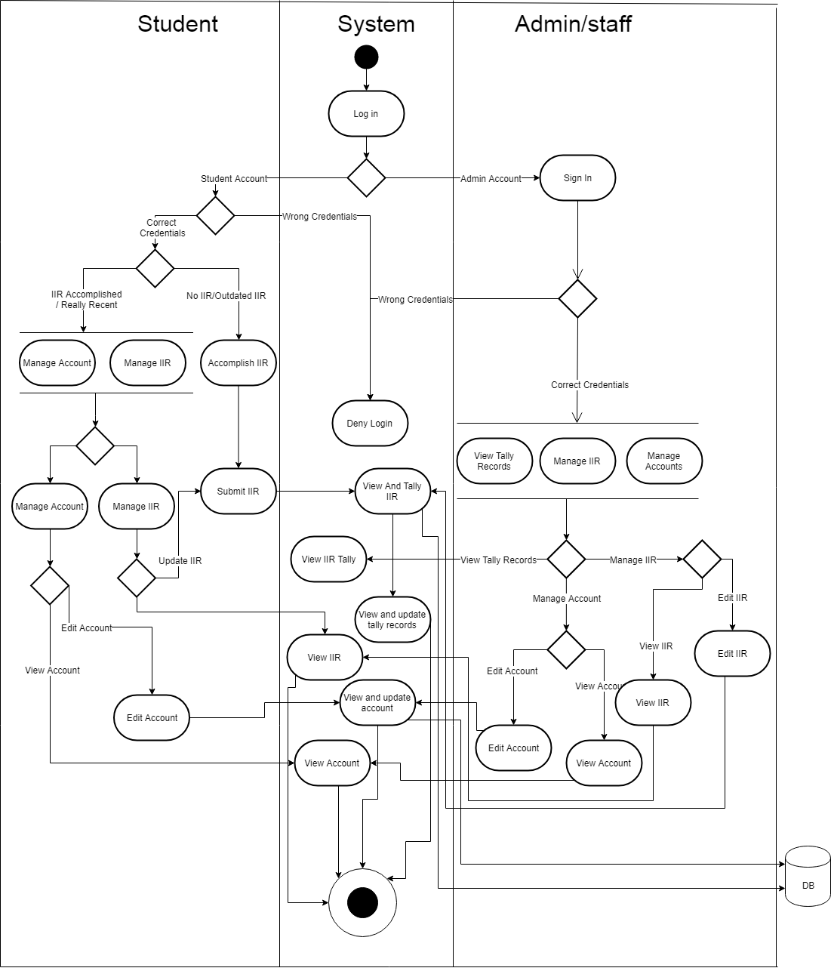

Fig 3.5. *General View Activity Diagram*

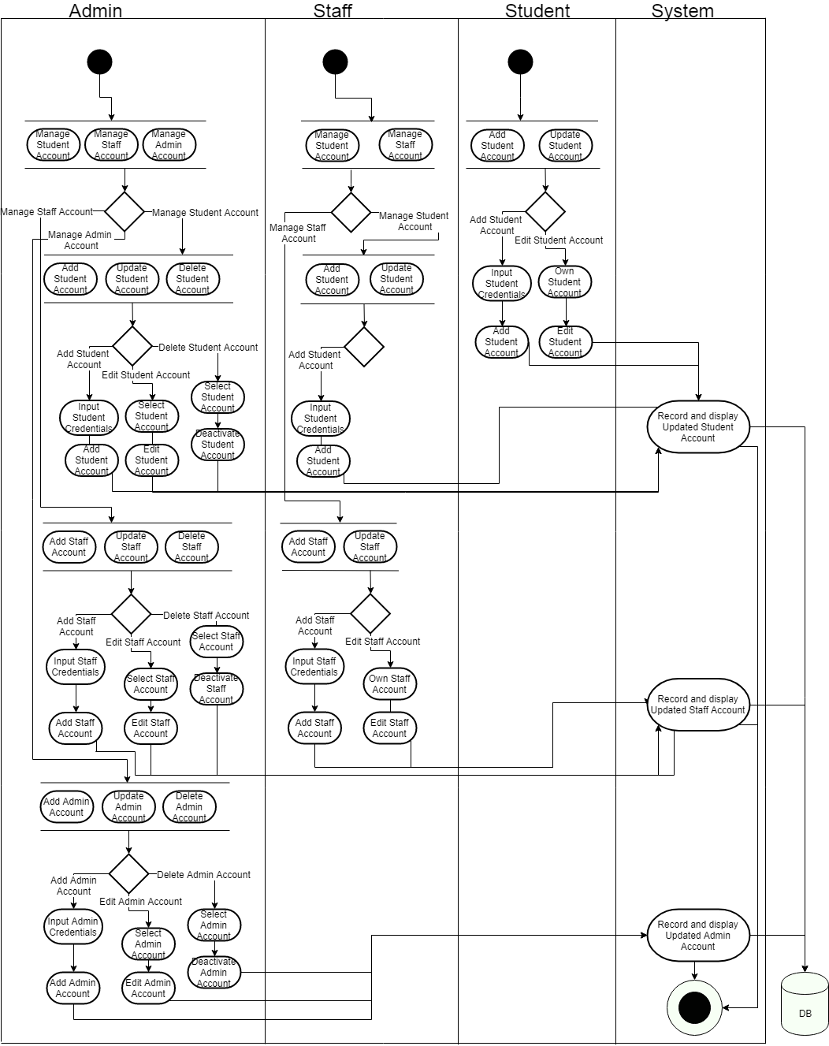

Fig 3.6*. Manage Accounts Activity Diagram*

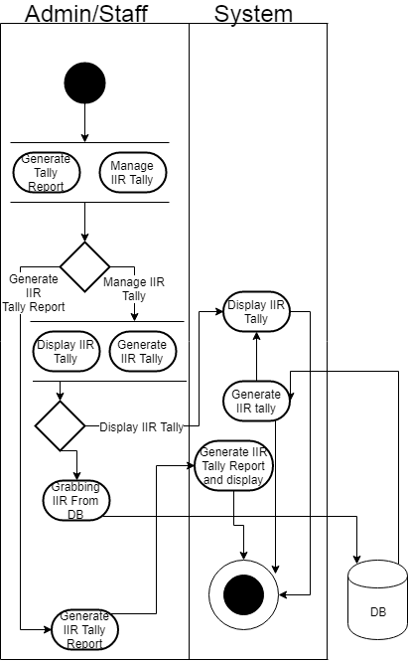

Fig 3.7. Manage Tally Report Activity Diagram

* + 1. Class Diagram

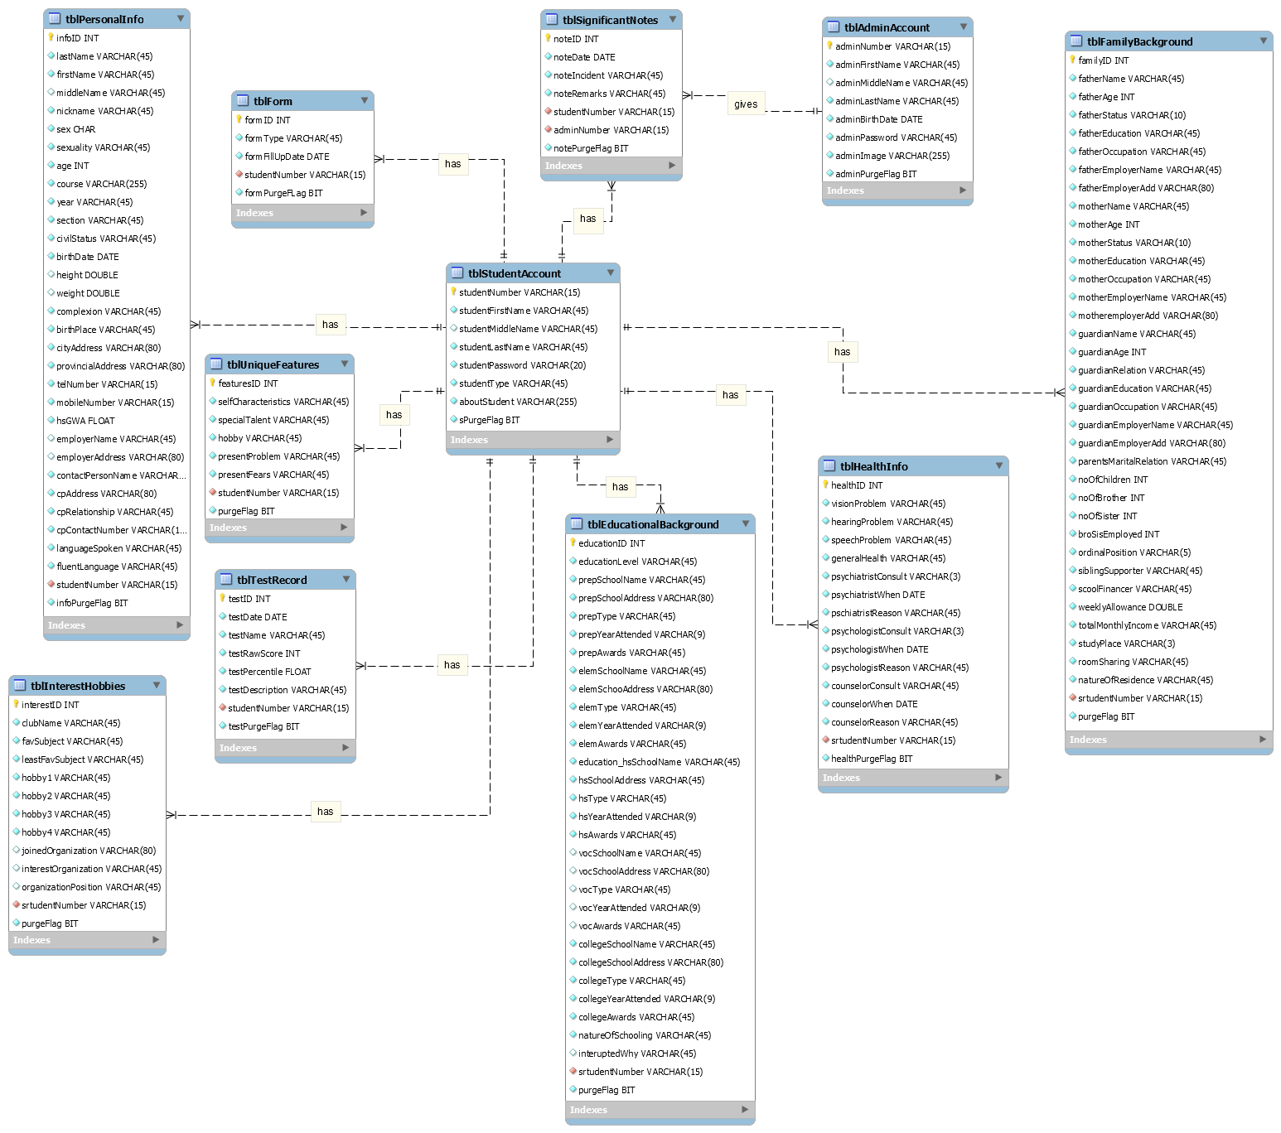

Fig. 3.8. *Entity-Relationship Diagram*

* + 1. **GUI Design**

**Screen Layout**

Student Side – Log-in

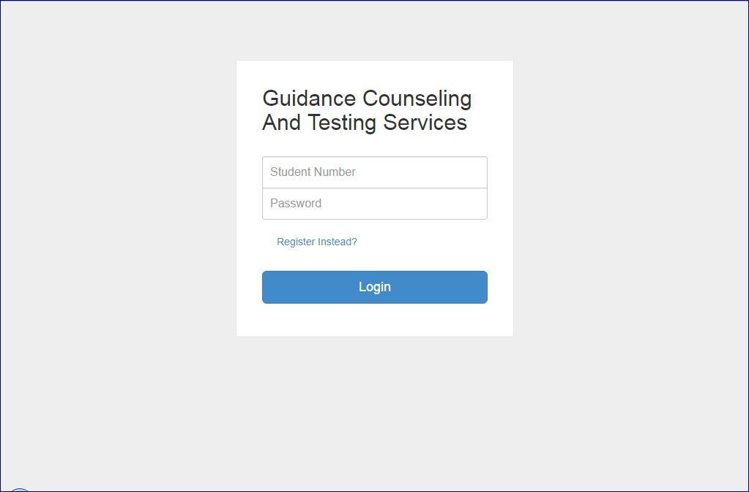

Student Side – Sign up

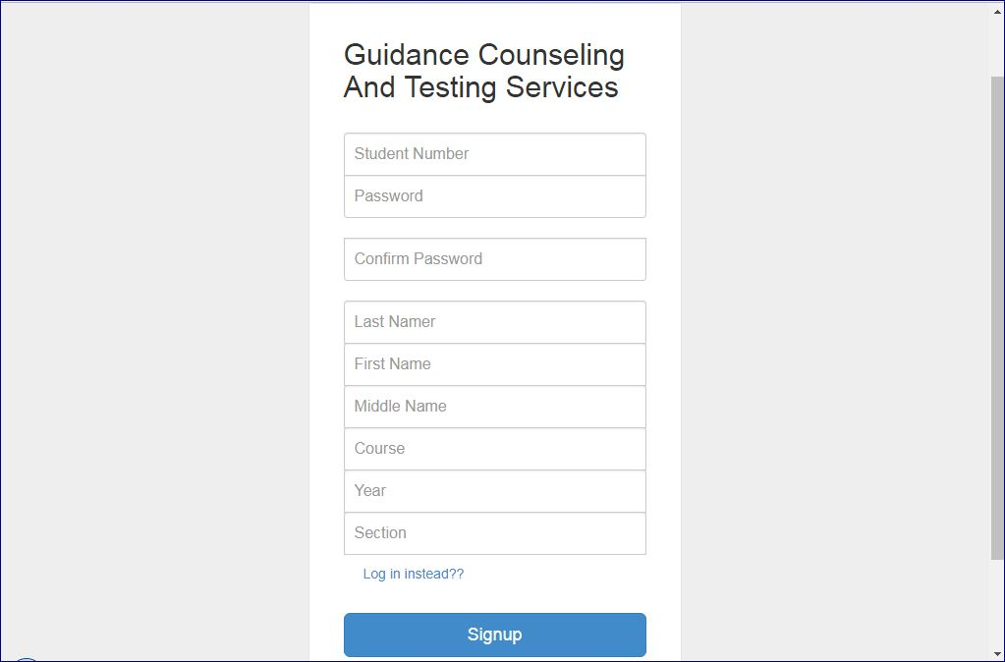

Student Side - Home

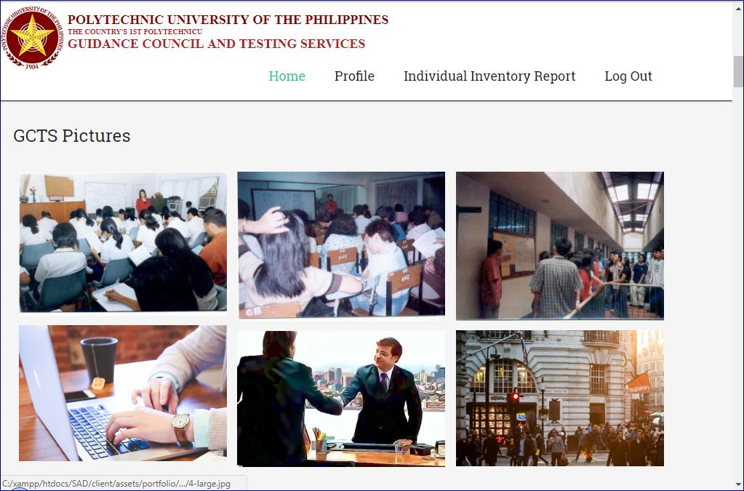

Student Sid – IIR Form Step 1

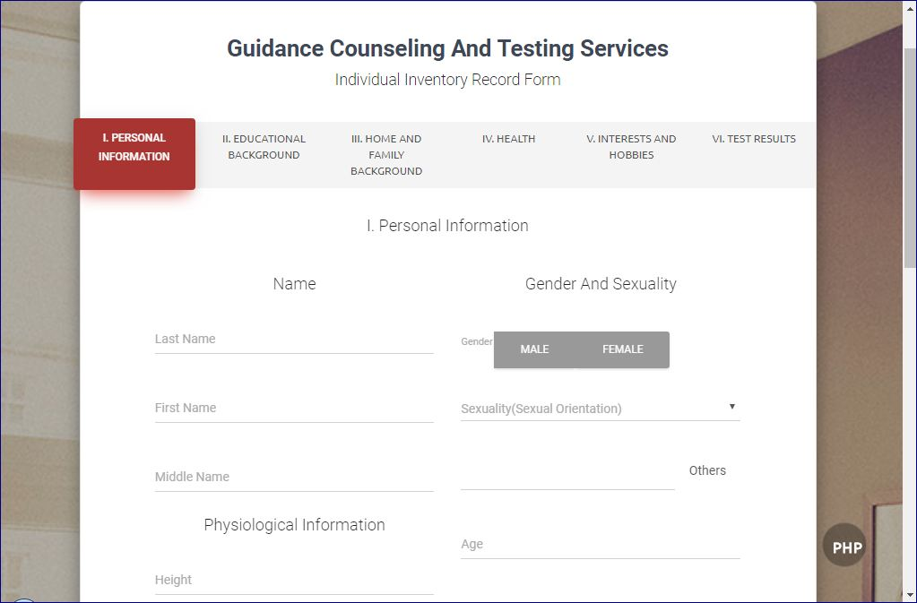

Student Side – IIR Form Step 2

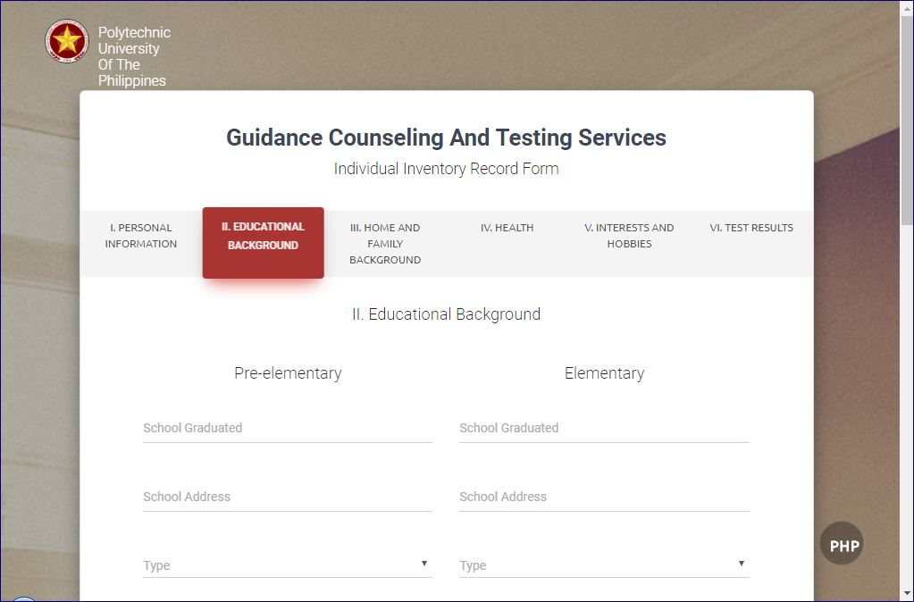

Student Side – IIR Form Step 3

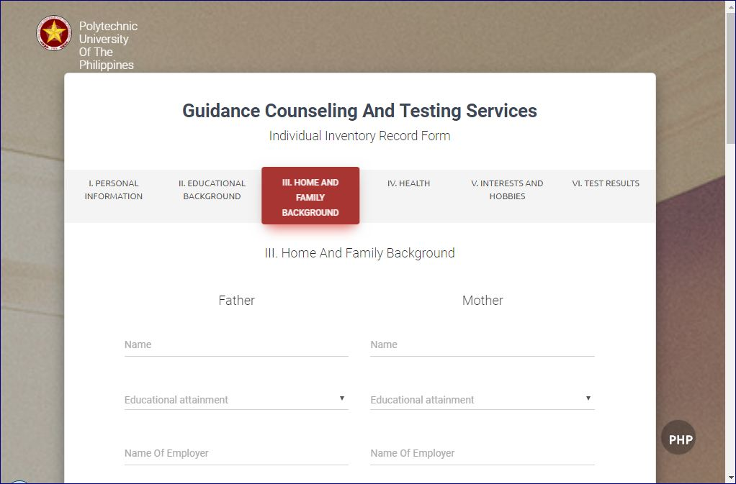

Student Side – IIR Form Step 4

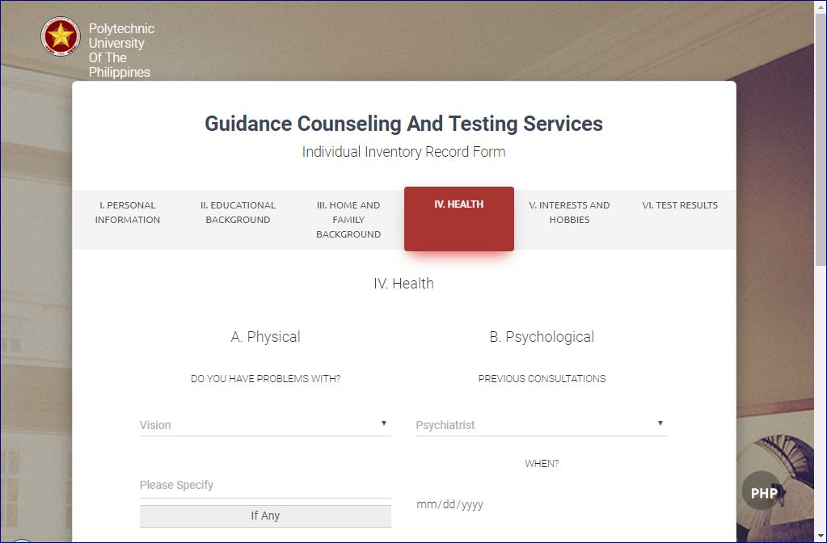

Student Side – IIR Form Step 5

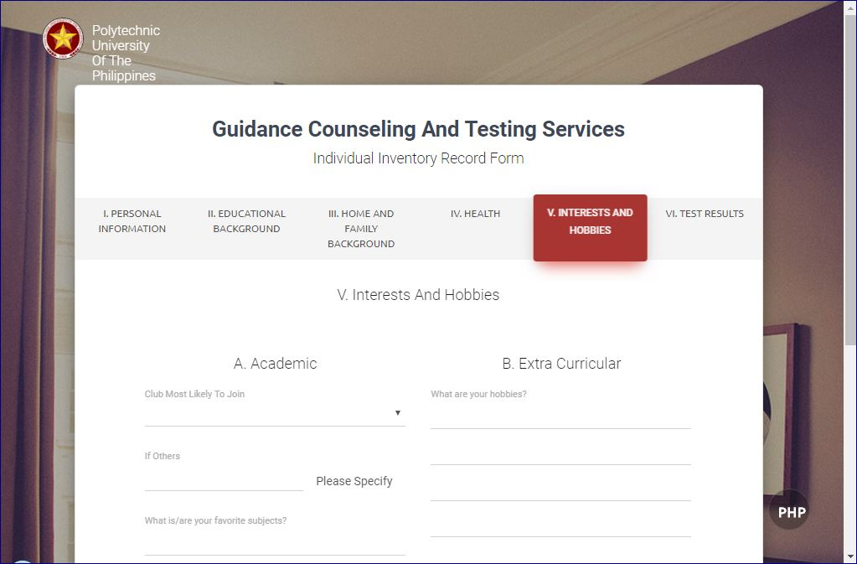

Student Side – IIR Form Step 6

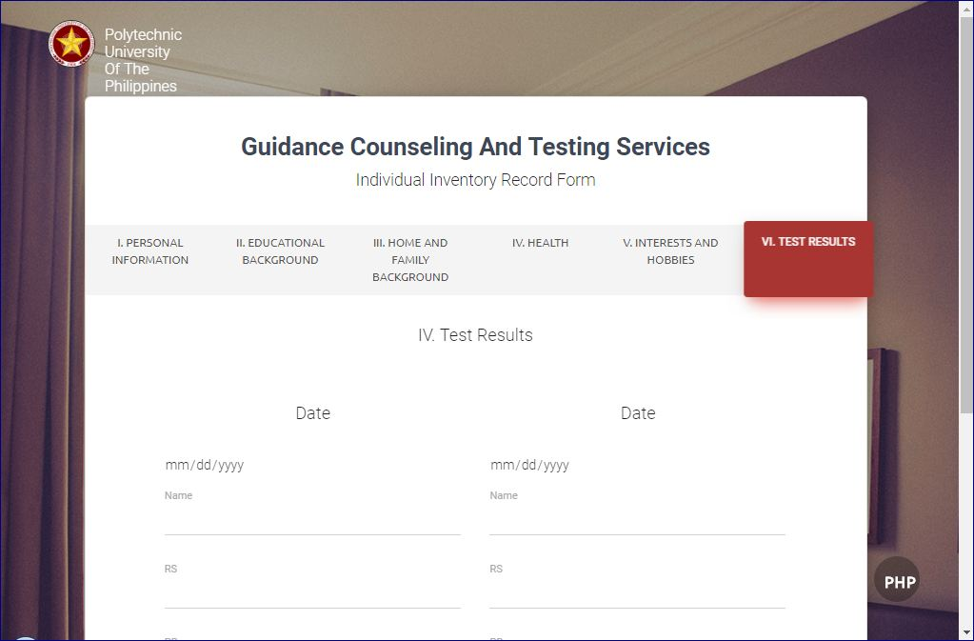

Student Side – IIR Form Update

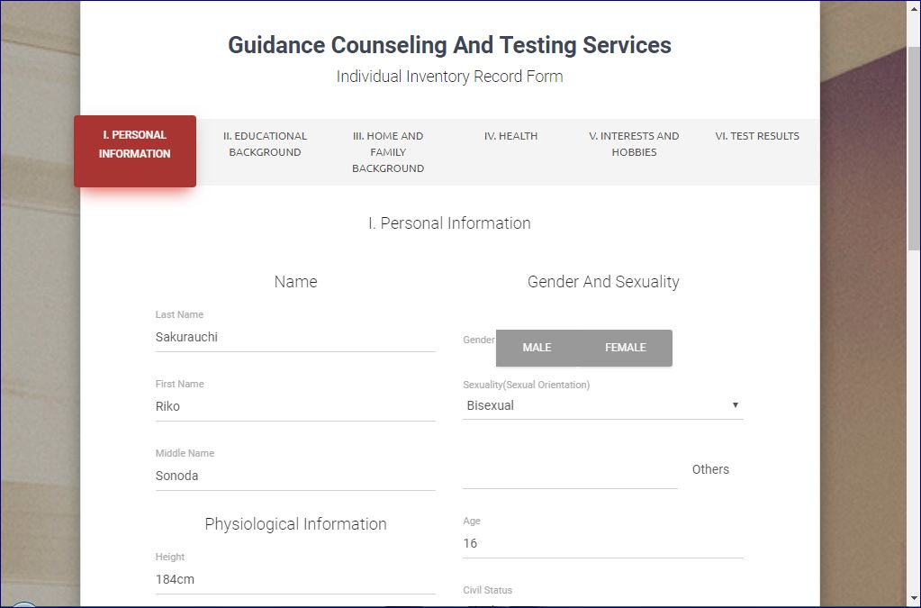

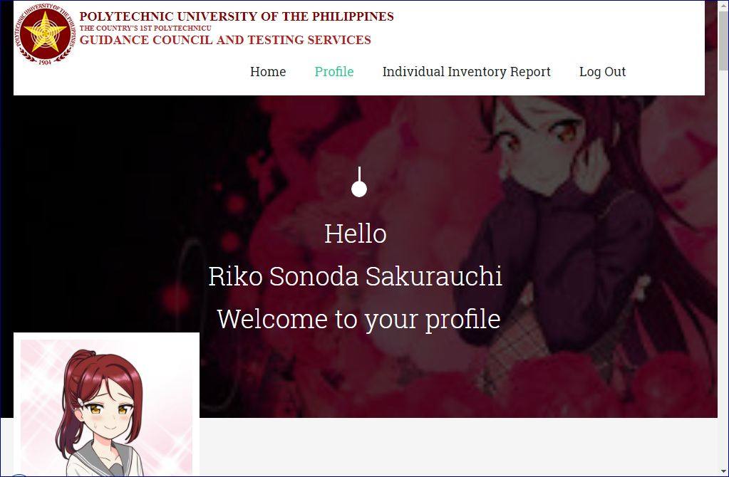Student Side – Profile

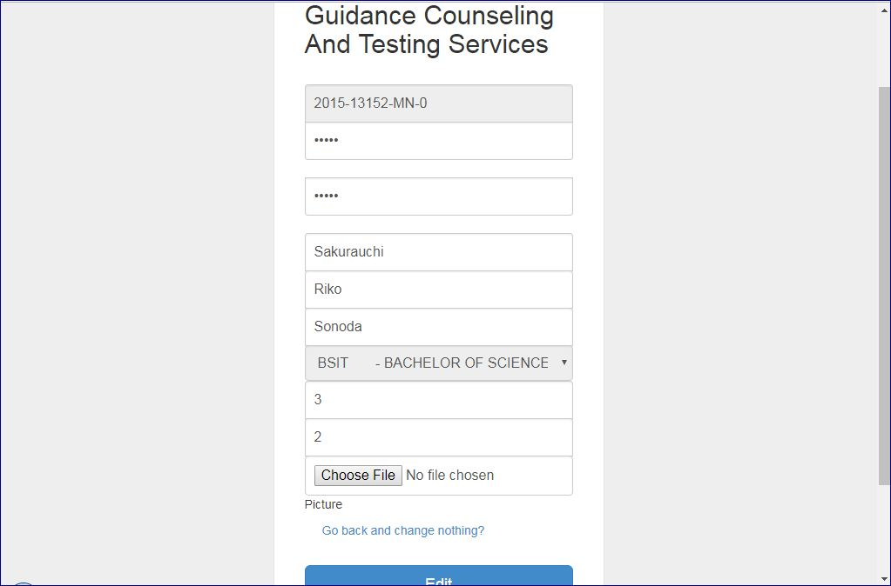Student Side – Update Account

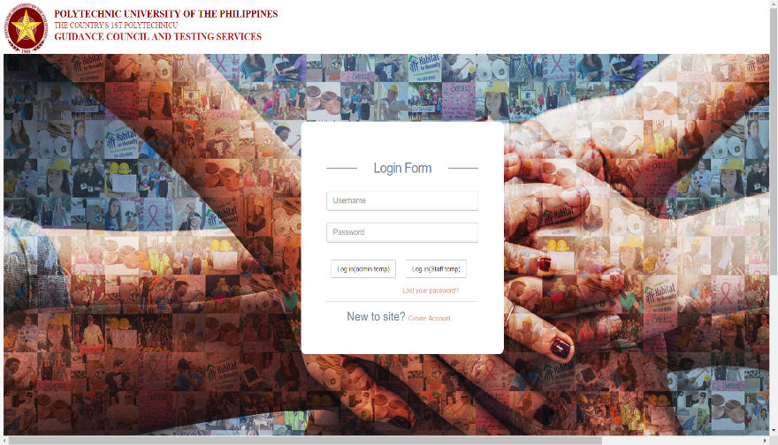Admin Side – Log-in

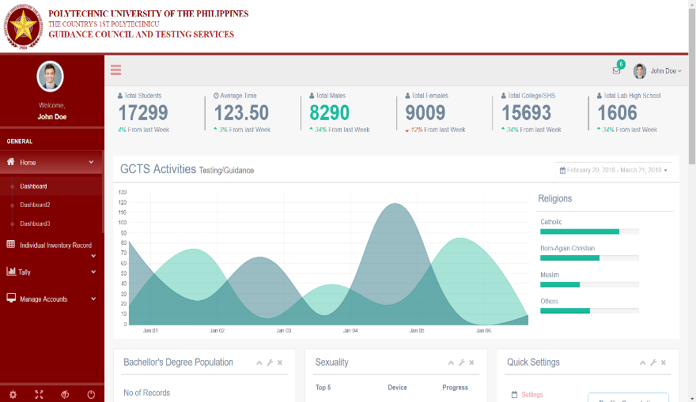Dashboard

Admin Side – IIR Form College

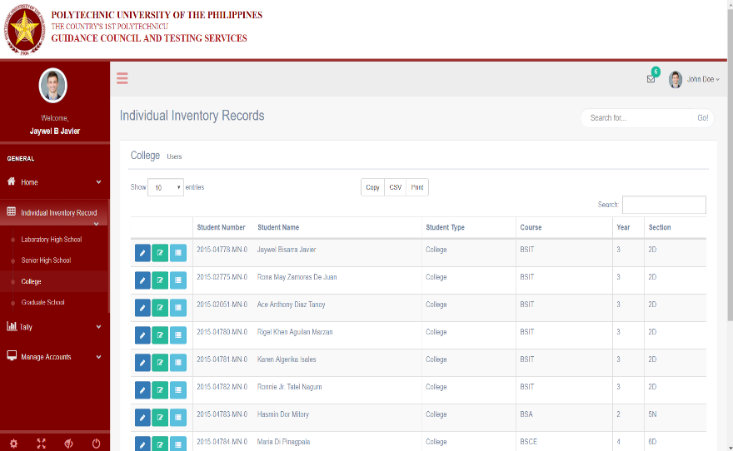

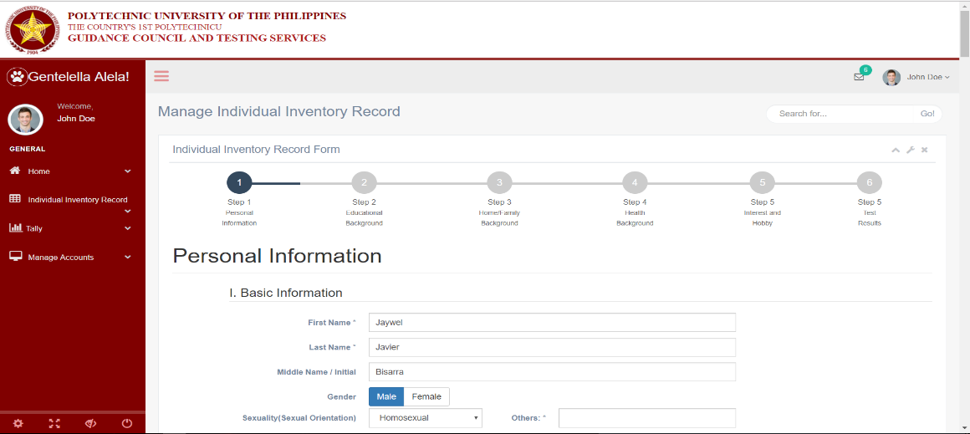Admin Side – IRR Form Step 1

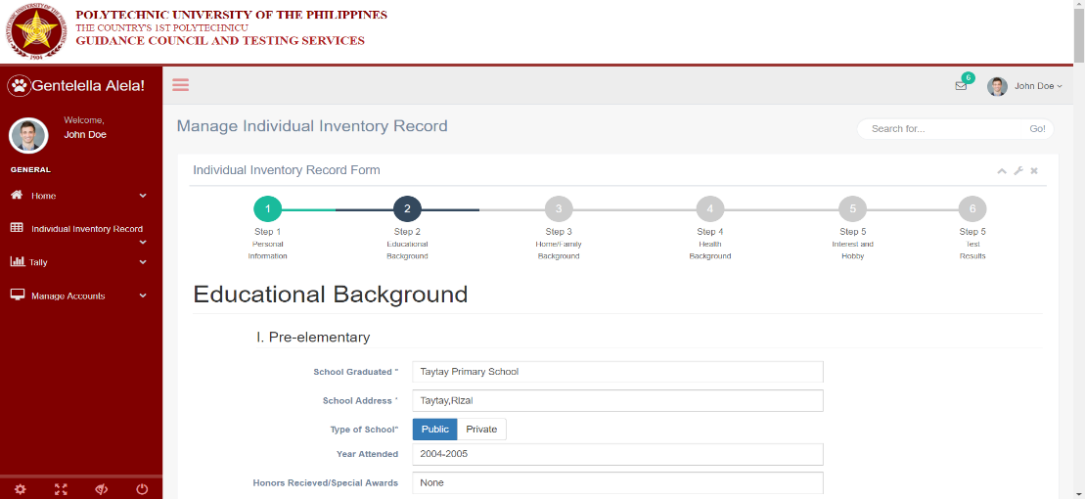Admin Side – IIR Form Step 2

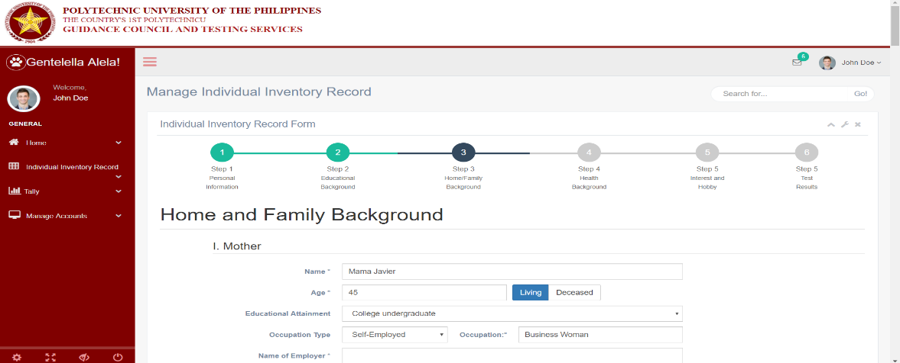Admin Side – IIR Form Step 3

Admin Side – IIR Form Step 4

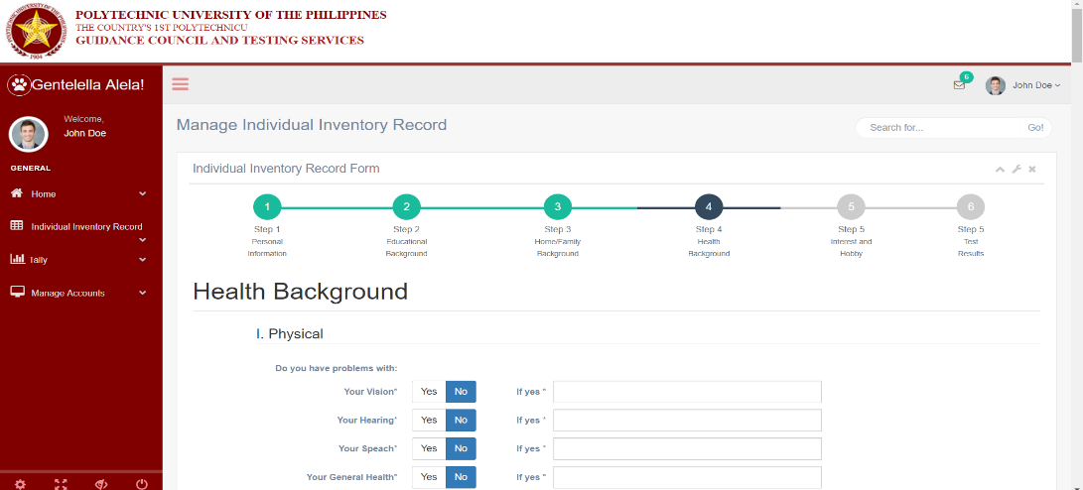

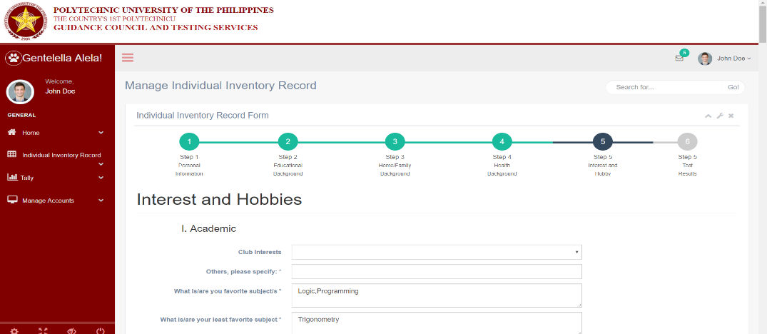Admin Side – IIR Form Step 5

Admin Side – IIR Form Step 6

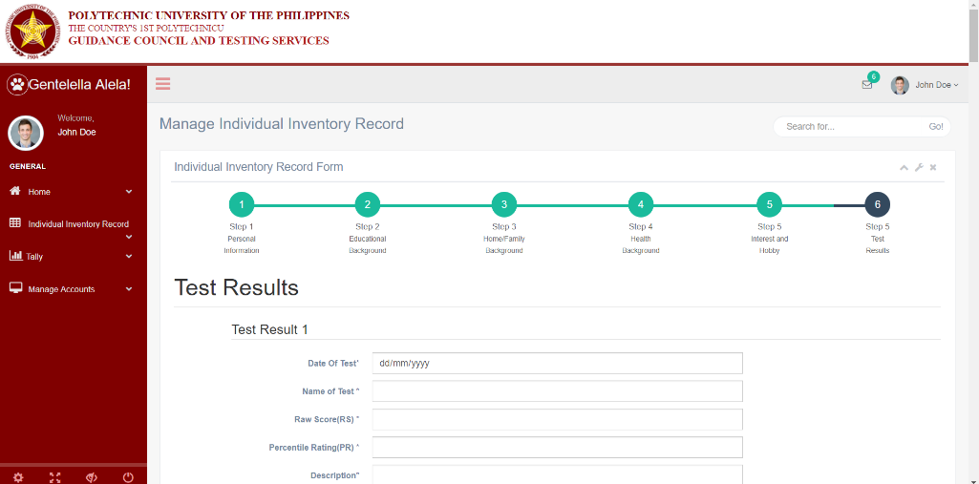

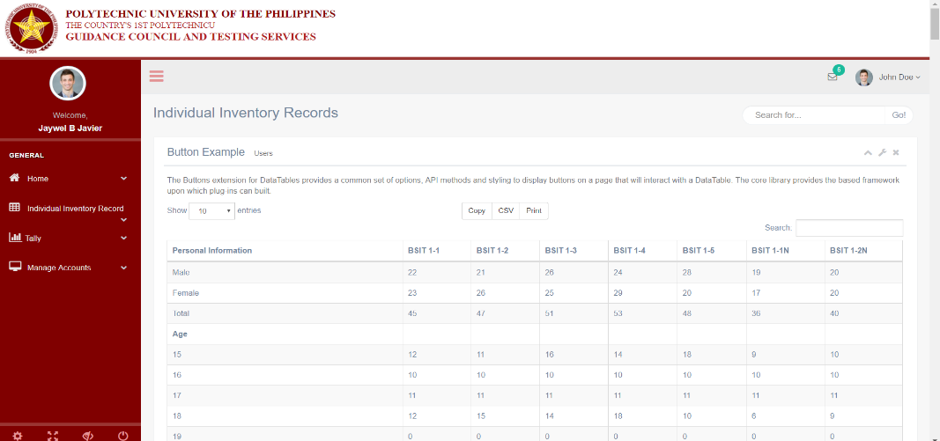Admin Side – Tally

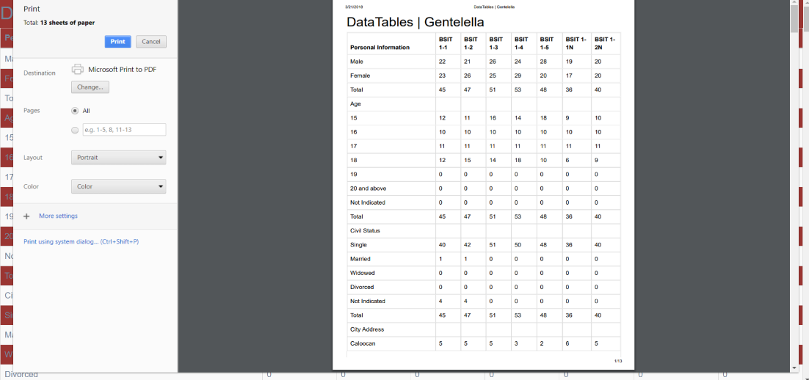Admin Side – Generate Tally Report

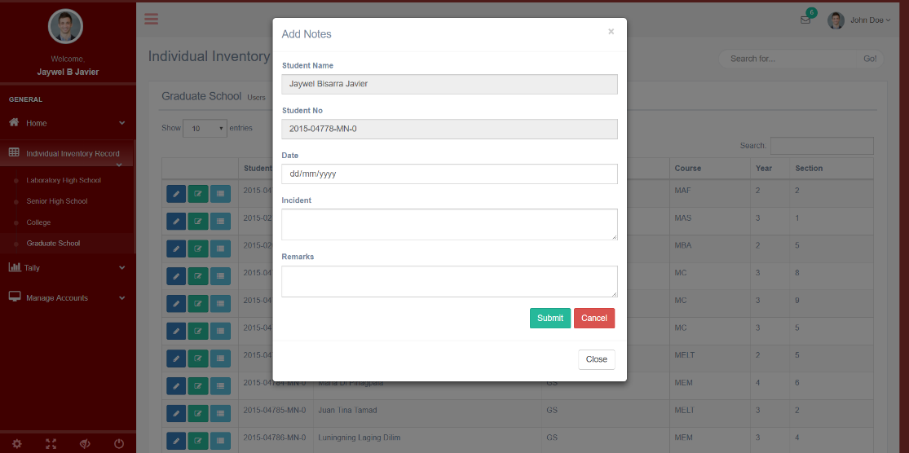Admin Side – Add Note

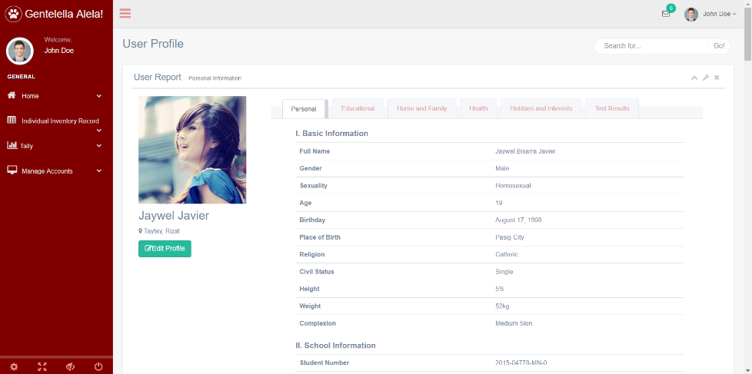Admin Side – View Account IIR

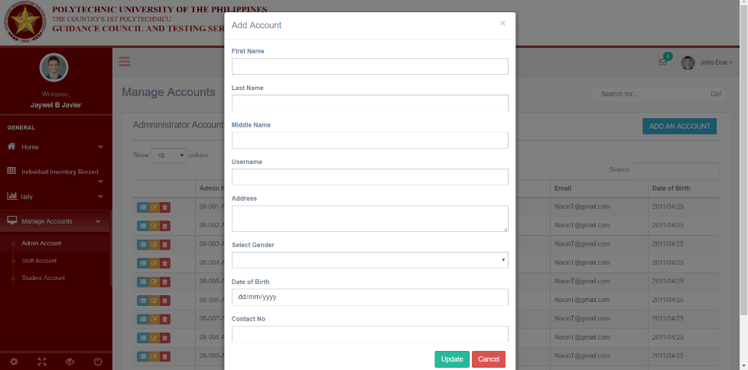Admin Side – Add Account

Admin Side – View Account

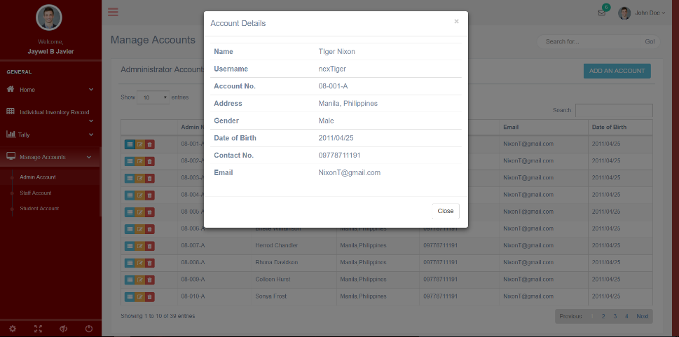

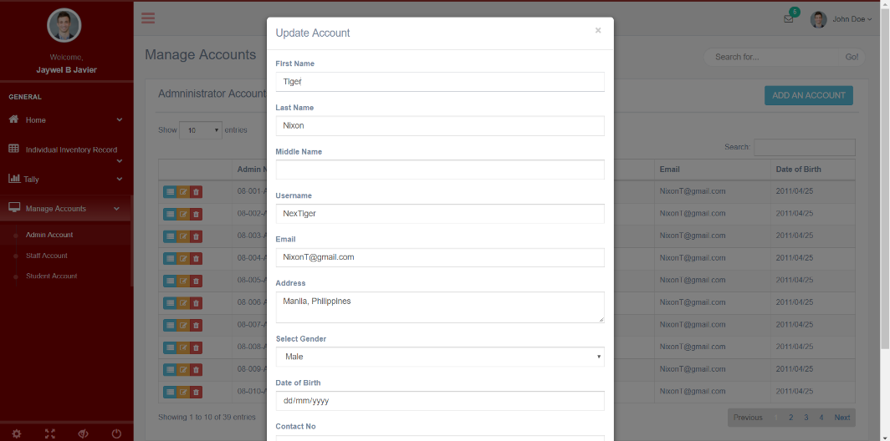Admin Side – Edit Account

**References**

**Guidance, Counseling, and Testing**

Clement, I. (2015). *Management of nursing services and education* (2nded.)

[Google Books Version]. Retrieved from <http://books.google.com.ph/books/about/Management_of_Nursing_Services_and_Educa.html?id=YmdrCgAAQBAJ&redir_esc=y>

Counseling. (n.d.). Retrieved March 20, 2018,

from https://www.merriam- webster.com/dictionary/counseling

Gladding, S. (2013). *Counseling: A comprehensive profession* (7thed.).

[Barnesandnoble eBook]. Retrieved

from <https://www.barnesandnoble.com/w/counseling-samuel-t-gladding/1100057775>

Guidance, Counseling and Testing Services. (n.d.). Retrieved

from <https://www.pup.edu.ph/studentservices/gcts/>

Kaplan, D., Tarvydas, V., & Gladding, S. (2014). *20/20: A vision for the future*

*counseling*. Retrieved from <https://www.counseling.org/knowledge-center/20-20-a-vision-for-the-future-of-counseling/consensus-definition-of-counseling>

Surbhi, S. (2016). *Difference between guidance and counseling.*

Retrieved from <https://keydifferences.com/difference-between-guidance-and-counseling.html>

**Individual Inventory Service**

Aspiras, A., & Oradiales, J. (2015). *Individual inventory service*.

Retrieved from <https://prezi.com/xjmt-h9egfge/individual-inventory-service/>

Anderson, E. D. (1954). *Current Practices in the Organization and Administration*

*of Guidance Services in Ninety-four Selected Secondary Schools.* [PDF file]. Corvilas, Oregon. Retrieved from <https://ir.library.oregonstate.edu/AndersonEricDean1954/>

Moser, L., & Moser, R. (1963). *Counseling and guidance: An exploration*. Retrieved from<https://books.google.com.ph/books/about/Counseling_and_guidance_an_exploration.html?id=G1Q7AAAAIAAJ&redir_esc=y>

Villar, I. G. (2009). *Implementing a comprehensive guidance and counseling*

*program in the Philippines.* Manila, PH: Aligned Transformations.

**Management Information System**

Cress, K. (2009). *5 types of Information Systems*. Retrieved

from <https://www.mindmeister.com/37310006/5-types-of-information-systems>

Kali, D., Hamdan, L., Shyouki, D. (2014). *E-Student Guidance System*.

Retrieved from <https://prezi.com/-ob8cxdapnjl/student-guidance-system/>

Laudon, K. C., Laudon, J. P. (2017). *Management information systems: Managing the*

*digital firm*. Retrieved from <https://www.amazon.com/Management-Information-Systems-Managing-Digital/dp/0134639715>

Opeyemi, A., Alabi, O., Ganiyu, O., Abisoye, B., Omokore, J. (2015). *A web-based*

*career guidance information system for pre-tertiary institution students in Nigeria*. Retrieved from <https://www.researchgate.net/publication/279957557_A_Web_Based_Career_Guidance_Information_System_for_Pre-Tertiary_Institution_Students_in_Nigeria>

Web-based student guidance information system. (2012). Retrieved

from <https://www.scribd.com/document/128078434/Web-Based-Student-Guidance-Information-System-Documentation>